USER AND MAINTENANCE MANUAL

ENVIROFLEX SNORKVAC SELF-SUPPORTING FUME ARMS

IN CANADA
Enviroflex International Inc.
17 Brownridge Rd., Unit 8
Halton Hills, Ontario
L7G 0C6
Phone : (905) 636-1177
Fax : (905)636-1178
Web Site : www.enviroflex.com
Email : info@enviroflex.com

IN USA
Enviroflex International Inc.
1051 Clinton Street
Buffalo, NY
14206-2823
Phone : (716) 883-2319
Fax : (716) 892-2139
Web Site : www.enviroflex.com
Email : info@enviroflex.com

Date: January 3, 2009

This manual is designed to inform the user about the proper assembly and use of the device. The user is advised to get fully acquainted with the contents of the manual before installation of the device and to handle the device according to the manual.

CONTENTS

SECTION PAGE

I. General information. 3
II. Purpose. 3
III. Reservations of the manufacturer. 4
IV. Technical data. 5
V. Construction. 7
VI. Mounting and assembly instruction 9
VII. Use and maintenance instruction and arm adjustment 11
VIII. Troubleshooting. 13
IX. Safety guidelines. 13
X. Accessories available. 13
XI. Parts list.

General information.
This manual contains basic technical data of the self-supporting suction arms type ENVIROFLEX® SNORKVAC™ and necessary information about installation, start and use of the devices. Before assembly and use of the device the owner and operator should read this manual carefully in order to fully understand the construction of the device, the principles of its operation, as well as its service and safety features. This will permit safe, efficient operation and assembly of the device. The Manufacturer reserves the right to make design and technological changes, which may improve the device.
The Manufacturer doesn’t take any responsibility if the device isn’t used according to manual.

Purpose.
ENVIROFLEX® SNORKVAC™ self-supporting Fume Arms are designed to easily position near the source of fume generation and to easily provide for the extraction of dust and gas emissions in the workplace.
The arms ensure the most efficient means of protecting the worker from the impurities by removing them before they enter the operators breathing zone. Proper Use of the self-locking joints and the flexible hoses ensures very easy extension of the hood close to the source of the contaminant.
Closing of the manual damper allows the operator to divert the air to other units on the same system, which increases efficiency of the complete ventilation ducting.

The ENVIROFLEX® SNORKVAC™ Self-supporting Fume Arms can be connected with:
- pivoting extension booms 3ft(.9M), 7ft.(2M), 10ft.(3M), 14ft.(4M), 161/2ft.(5M) and 19 1/2ft.(6M) in length giving you a maximum reach of 33 1/2ft.(10M)
- different filtering devices or with fans
- energy efficient automatic equipment
Some of the possible areas for use of the Enviroflex® Snorkvac™ Fume Arms are:
- chemicals
- gluing
- grinding applications
- light dusts
- painting
- polishing
- soldering
- welding processes

Limitation of use :
- For all non stainless steel versions - corrosive and caustic gases and dust
- For version with light installed in the hood – corrosive, caustic and explosive gases and dust

Reservations of the manufacturer.
The Manufacturer reserves the right to make design and technological changes, which may improve the device. Before mounting and use of the arm the owner and operator should read this manual carefully in order to understand fully the construction of the device, the principles of its operation, as well as its service and safety features. This will permit safe, efficient operation and assembly of the device.
The Manufacturer doesn’t take any responsibility if the device isn’t used according to the manual.

Technical data.

Drawing 1.
Working ranges and reaches of arms.

Table 1. Product range.

Model |  | Arm reach R_{max}  [feet] / [m] | Arm diameter  [inches] / [mm] | Available hood diameter  [inches] / [mm]
1 | 103.1000 | 3 / 1.0 | 3 / 75 | 6 / 160
2 | 103.1001 | 5 / 1.5 | 3 / 75 | 6 / 160
3 | 103.1003 | 5 / 1.5 | 4 / 100 | 8 / 200
4 | 103.1003 | 7 / 2.0 | 4 / 100 | 8 / 200
5 | 103.1004 | 8 / 2.5 | 4 / 100 | 8 / 200
6 | 103.1062 | 7 / 2.0 | 5 / 125 | 10 / 250
7 | 103.1063 | 10 / 3.0 | 5 / 125 | 10 / 250
8 | 103.1006 | 10 / 3.0 | 6 / 160 | 12 (14) / 315 (350)
9 | 103.1007 | 14 / 4.0 | 6 / 160 | 12 (14) / 315 (350)
10 | 103.1008 | 7 / 2.0 | 8 / 200 | 14 (20) / 350 (500)
11 | 103.1009 | 10 / 3.0 | 8 / 200 | 14 (20) / 350 (500)
12 | 103.1010 | 14 / 4.0 | 8 / 200 | 14 (20) / 350 (500)

A large variety of hoods can be manufactured to suit a particular requirement. Different diameters, constructions, material are available.
All hoods are equipped for installation of an optional light kit.

Dimensions of mounting flanges for Enviroflex® Snorkvac™ Fume Arms:

Diameter of arms  [inches] | n  - | D  [in.]/[mm] | D1  [in.]/[mm] | D2  [in.]/[mm] | D3  [in.]/[mm] | h  [in.]/[mm]
3” | 4 | .26/6.5 | 2.85/72 | 4.41/112 | 4.92/125 | .20/5
4” | 4 | .26/6.5 | 3.78/94 | 5.28/134 | 5.83/148 | .20/5
6” | 6 | .28/7 | 6.02/153 | 7.68/195 | 8.66/220 | .26/7
8” | 8 | .35/9 | 7.79/198 | 9.68/246 | 10.83/275 | .35/9

Construction

ENVIROFLEX® SNORKVAC™ – Wall or ceiling mounted arm

ENVIROFLEX® SNORKVAC™ – Bench mounted arm

Drawing 2.
Construction of self-supporting suction arm.

- The basic components which are in all versions:
- The rotating socket which consists of the outer sleeve (1) (cast aluminum) with the connecting flange and the other inner sleeve (2) (steel). The sleeves for 4”, 6”, and 8” arms are connected together by means of a thread. The rotation of the sleeves in the range of 350° is limited by a stop. The 3” arm does not use the thread so it can be rotated 360°. The complete unit is electrostatically powder coated, with "thermo-hardened" paint.
- The arms I (3) and II (4) - pipes (rolled sheet steel), covered and painted as above.
- The flat joints inner (5) and outer (6) – For 6” and 8 “versions - Cast Aluminum painted by the electrostatic method (as above), and bolted to the inner sleeve of the rotating socket and to the arm I and II. For 3”, 4” version - steel elements also painted and bolted as above.
- The friction joints are separated with the frictional insert and washer. These elements are bolted together.
- The flexible hose (7) connecting the elements of the self-supporting arm (“bending” of device) are attached by means of gear clamps (8).
- The hood (10) is fabricated of aluminum sheet with the handle (9), which facilitates easy placement of the unit in the required position. The hood is added according to the version and powder coated with polyestro-epoxide "thermo-hardened" paint.
- The manual damper installed on the arm tube II (4) near the hood.

- Wall or ceiling mounted version:
- Mounted via the flange of the outer sleeve (of rotating socket) to the support structure (bracket) by means of six screws M6 (3/8”).
- To aid the up and down movement of the arm, each 4”, 6” and 8” unit is provided with an encapsulated spring (11) and fixed to the inner sleeve of the rotating socket and the tube of arm I.

- Portable (Bench Mount) version:
- Mounted via the flange of the outer sleeve (of rotating socket) to the support structure by means of bolts M6 (3/8”).
- To aid the up and down movement of the arm, each 4”, 6” and 8” unit is provided with a cylinder springs fixed to the inner sleeve of the rotating socket and the tube of arm I. These springs are placed inside the tube.
- To protect the arm from falling below a certain level, a steel cable is attached parallel to the spring as above (6” and 8” versions).

- Optional hood accessories (special order):
- Inlet Hood Grill to prevent rags and large objects from entering the arm.
- Light Kit with Control Switch for light and/or fan.

Mounting and assembly instruction
Mounting instructions:
- The self-supporting suction arm is fixed to the bracket installed on the wall or to the pivoting extension boom that enlarges the working range of the device, or to other element having a connecting flange with dimensions the same as the inner sleeves of the rotating socket.
- NOTE: THE SOCKET'S AXIS (OF FUME ARM) MUST BE VERTICAL!
- The rotating socket should be fixed so as the protrusion on the outer sleeve that limits the rotating is opposite the wall, bracket or the pivoting axis of the pivoting extension boom – see Drawing 3.
Note: In case of the installing the bracket at a height less than 8ft. (2,5m) above the floor, the bracket should be turned up-side-down and replace the standard connector to the welded-high one.
- ENVIROFLEX SNORKVAC™ self-supporting fume arm
- Bracket
- Fan
- Gear clamp
- Flexible hose
Drawing 3.
Example of the assembly of the self-supporting arm in the ducting.
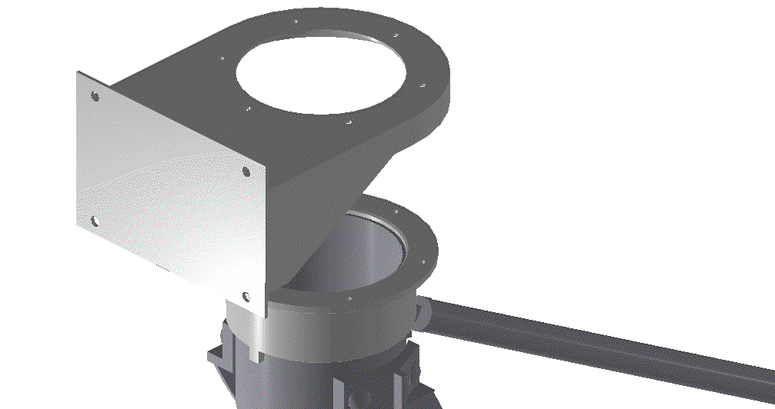
protrusion –
mount at wall side!
rotary socket of fume arm
wall mounting bracket

Drawing 4.
Mounting the socket of Fume Arm.

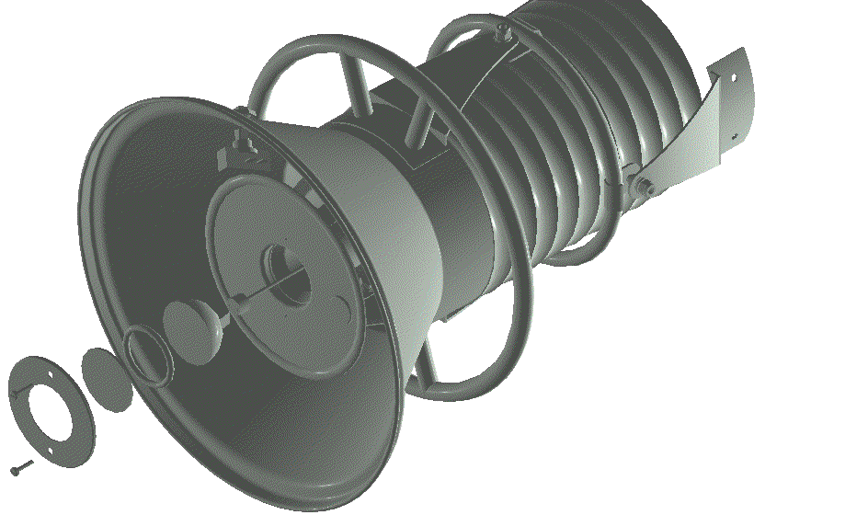Mounting optional light kit:
6
5
4
3
2
1
10
8
7
- wire set
- halogen lamp („cold type”) 12VAC/35W
- o-ring seal
- protecting glass
- mounting plate
- bolts
- control switch
- hood
- wire seal
- shield
- light kit dome
Drawing 5.
Light kit mounting.

Before mounting the light kit, remove the plug from the side of the hood (for mounting a control switch) and unscrew the plate at the centre of the hood (for mounting halogen lamp). You need also to remove the hose from the hood joint (4”, 6” and 8” versions) or take the hood off (3” version).
Do the following after you have completed the above:
- place the wire set (1) moving it through the wire seal (9) inside the light kit dome (11)
- connect the control switch (7) to the wire set (1) and mount the switch on the side of hood (8)
- plug in (connect) the halogen lamp (2) into the wire set socket
- put halogen lamp (2), o-ring seal (3), protecting glass (4) together and place them inside the hood
- Install the mounting plate (5) with using the bolts (6).

Use and maintenance instruction and arm adjustment
The installed self-supporting arm should be checked for freedom of movement and rotation of the socket. If excessive resistance exists at the joints, adjustment must be carried out. It is recommended to spray the hood (before work, each day) with antispatter preparation. It will make easier cleaning of the device every day.

The maintenance of the device is carried out periodically as follows:
- every day
- Clean inner surface of the hood and outer surface of the arm.
- Check self-locking of the arms and the hood, and adjust it if it is necessary.
- once per month
- Grease the rotating socket with bearing grease which does not react with aluminum.
- Check self-locking and adjust if necessary.
- once every 3 months
- Disassemble the flexible hoses; clean up the inside of the self-supporting arm (warm water with detergent).
- Replace the glass panel in the spotlight.
Adjustment.
For adjustment of any joint, you need to use two wrenches.
Adjustment is made with arm horizontally levelled.
- Adjust the 1st set of the flat joints between the arms by holding the Bolt and tightening the self-locking nuts on the joint pairs. With 3” version of arms you need one wrench; knob nuts placed in this version are used for locking the nuts.
- Adjust the 2nd set as above.
The horizontally positioned arm shouldn't fall down when letting go.
Arm diameter | Wrench size
 | 1st joint | 2nd joint | 3rd joint
3” | 13 | 13 | 10
4” | 17 | 17 | 10
6” | 21 | 21 | 13
8” | 21 | 21 | 13

- Adjust the hood joint (3rd) with the same way as described above.

Troubleshooting.

Symptoms | Possible reasons | Solution
The arm will not stay where it is placed | The joints require adjustment | Adjust the joints (item VIII)
Stronger resistance during rotation of the arm | Lack of grease in the rotating socket | Grease the rotating socket
Decrease in air volume | A/ Hose not properly connected to Arm tubes.  B/ The flexible hose is damaged.  C/ The Damper is closed | A/Reconnect Hose.  B/ Replace Damaged Hoses.  C/ Open Arm Damper

Safety guidelines.
For the safe operation of the ENVIROFLEX® SNORKVAC™ self-supporting Fume Arms:
- DO NOT rotate the arm beyond the noticeable "resistance" (4”, 6” and 8” versions).
- DO NOT bend it beyond vertical axis of the rotating socket.

ACCESSORIES AVAILABLE.
- Light kit – Complete set of halogen lamp with control switch, set of wires and mounting elements destined to be placed in the hood.
- Hoods – it’s possible to get hoods with diameter φ14” for 6” arm diameter, φ20” for 8” arm diameter. Also a gap hoods are available.
- Mounting brackets – the brackets are destined to mount the arm on the wall – see Drawing 2. There are brackets for all types of ENVIROFLEX® SNORKVAC™ arms.
- Fans – centrifugal units which can be mounted on the brackets together with arm or in the ducting (e.g. Drawing 2).
- Pivoting booms – devices which enlarge the working range of arm.

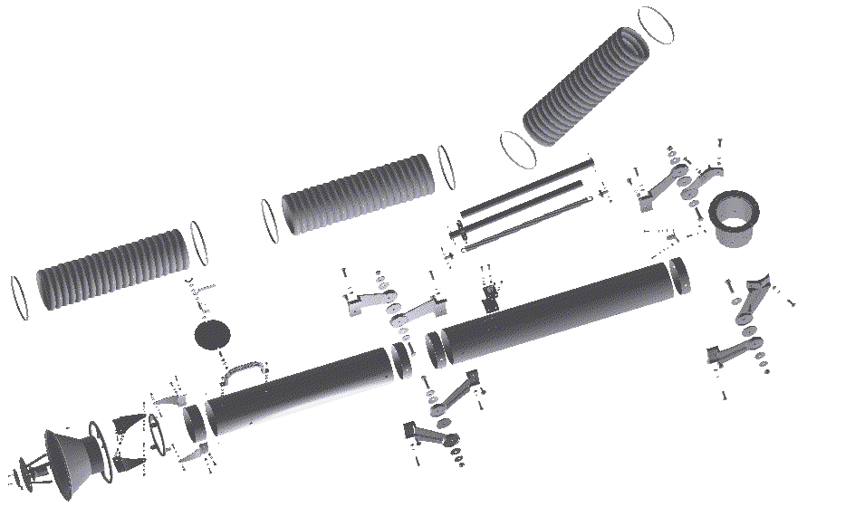

103.1007 Complete Fume Arm (Drawings A1, B1, C1, D1, E1

82
82
82
82
82
82
85

84
81
12
13
A1
C1
D1
B1
E1

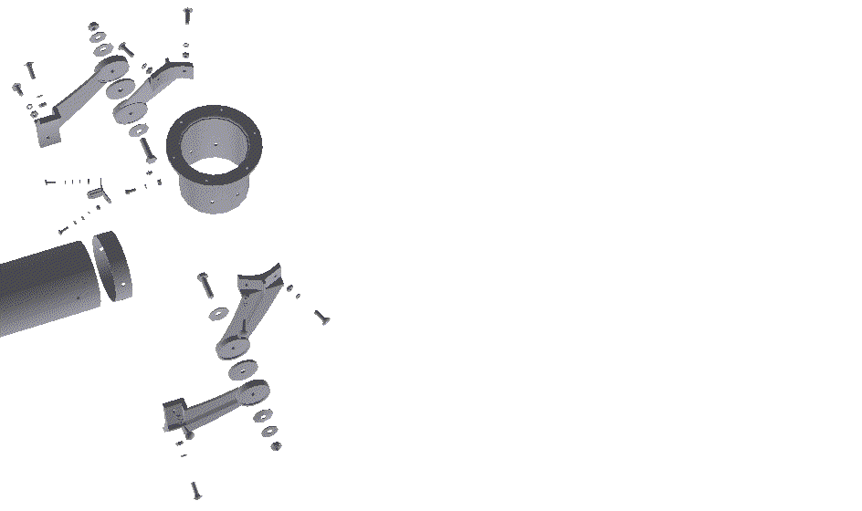103.1007 (Drawing A1 Socket Assembly)
22

24
32
34
31
47
69
46
69
47
3
9
46
31
34
32
31
34
32
12
14
36
73
38
75
32
34
31
A1
47
57
19
39
40
40
41
42
57
47
2
9
4
1

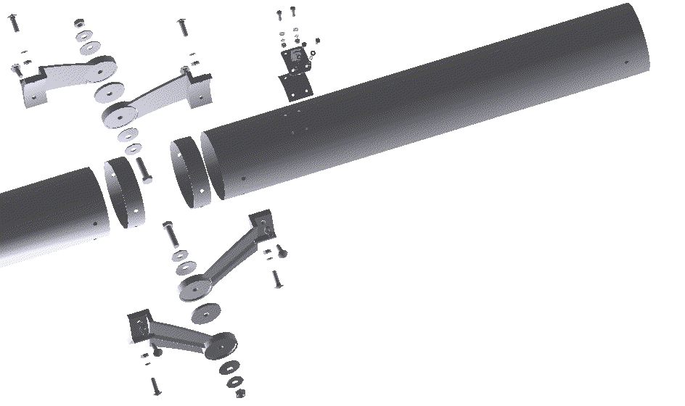103.1007 Drawing B1 (Middle joint)
36
38
35
6
10
8
48
69
46
36
38
35
36
38
35
58
69
48
35
38
36
14
12
38
36
48
69
58
14
13
35
38
36
35
46
69
48
7
10
5
35
38
36
36
38
35
B1
39
40
41
42
19a
39
40
41
42
16

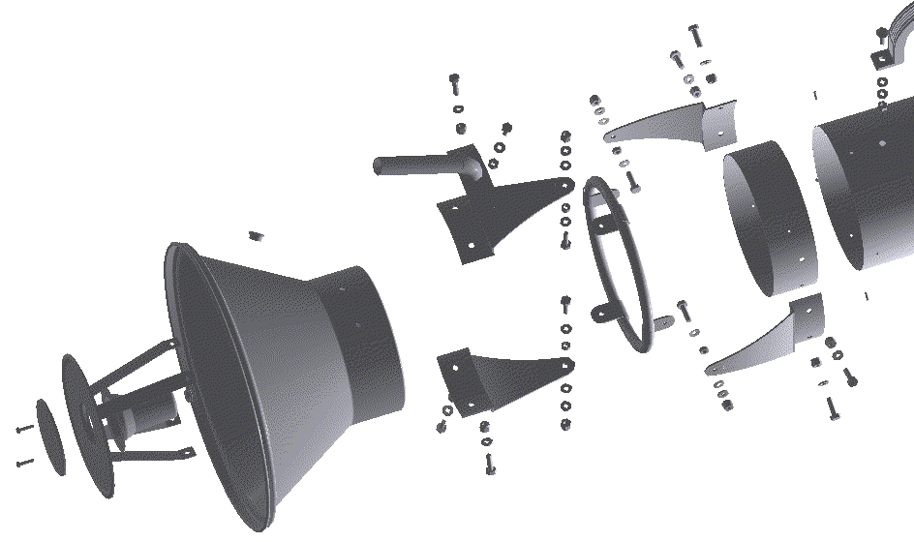103.1007 Drawing C1 (Hood joint and hood)
13
79
P4
P5
P9
P7
P9
P3
P2
60
80
40
41
42
79
C1
P8
P3
P5
P4
P3
P9
P7
P2
P9
P5
P1
P4
P2
P3
P9
P7
P9
P5
P4
P2
P3
P5
P4
P6
64
62
63
65
66
68
P2
70

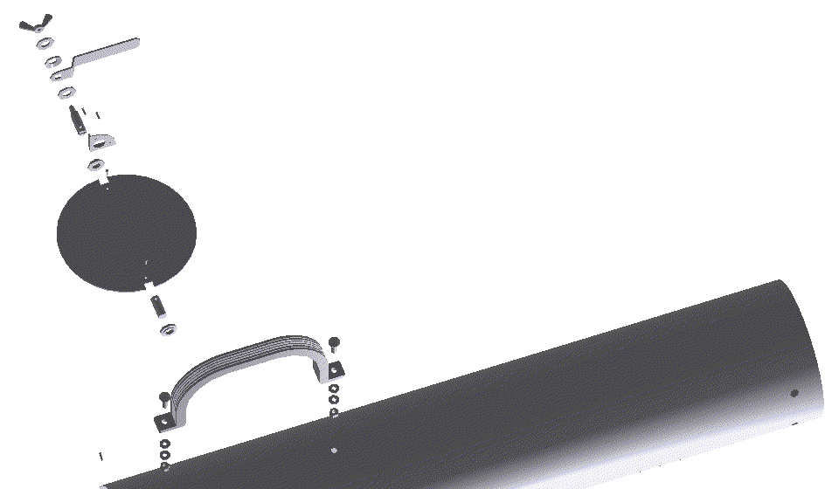103.1007 Drawing D1 (Damper)
70
80
40
41
42
13
40
41
42
79
70
74
41
33a
28
33a
26
79
30
29
79
25
27
29
D1

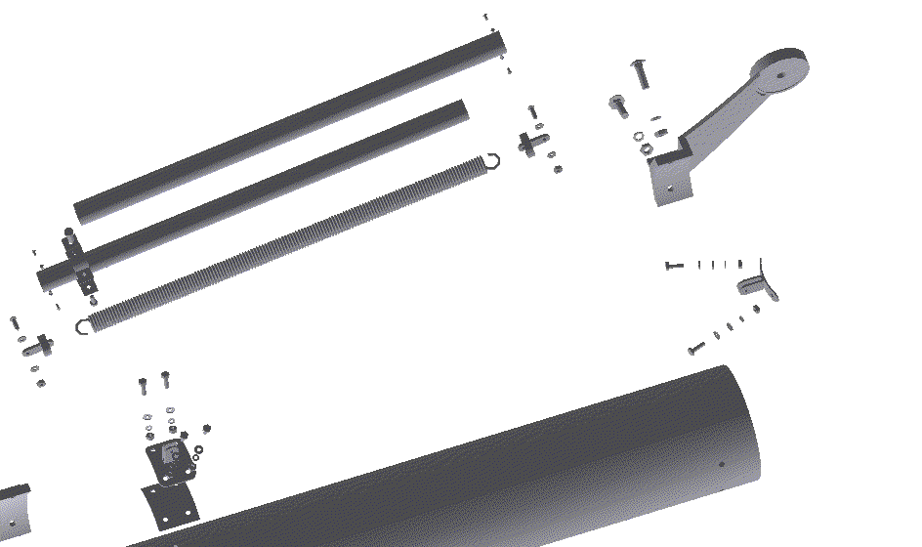Drawing E1 (Spring)
5
79
50
43
44
88
18
45
20
39
40
41
42
19a
16
40
40
41
42
39
39
40
40
41
19
42
31
34
32
3
45
20
17
49
50
43
44
79
86
87
89
49
E1

Parts list (refer to Drawing A1(Page 15)

φ6” Wall or Ceiling Mount
Arm
No | Description | Qty | Arm Model
 |  |  | 103.1005 | 103.1006 | 103.1007 | 103.1016 |  | 103.1017 | 103.1018
 |  |  | Part Number
1 | Joint 1 | 1 | 103.1005.1 | 103.1006.1 | 103.1007.1 | 103.1016.1 |  | 103.1017.1 | 103.1018.1
2 | Joint 2 | 1 | 103.1005.2 | 103.1006.2 | 103.1007.2 | 103.1016.2 |  | 103.1017.2 | 103.1018.2
3 | Joint 3 | 1 | 103.1005.3 | 103.1006.3 | 103.1007.3 | 103.1016.3 |  | 103.1017.3 | 103.1018.3
4 | Joint 4 | 1 | 103.1005.4 | 103.1006.4 | 103.1007.4 | 103.1016.4 |  | 103.1017.4 | 103.1018.4
5 | Joint 5 | 1 | 103.1005.5 | 103.1006.5 | 103.1007.5 | 103.1016.5 |  | 103.1017.5 | 103.1018.5
6 | Joint 6 | 1 | 103.1005.6 | 103.1006.6 | 103.1007.6 | 103.1016.6 |  | 103.1017.6 | 103.1018.6
7 | Joint 7 | 1 | 103.1005.7 | 103.1006.7 | 103.1007.7 | 103.1016.7 |  | 103.1017.7 | 103.1018.7
8 | Joint 8 | 1 | 103.1005.8 | 103.1006.8 | 103.1007.8 |  | 103.1016.8 | 103.1017.8 | 103.1018.8
9 | Friction insert I 70 | 2 | 103.1005.9 | 103.1006.9 | 103.1007.9 |  | 103.1016.9 | 103.1017.9 | 103.1018.9
10 | Friction insert II 60 | 2 | 103.1005.10 | 103.1006.10 | 103.1007.10 |  | 103.1016.10 | 103.1017.10 | 103.1018.10
12 | Tube I 160 | 1 | 103.1005.11 | 103.1006.11 | 103.1007.11 |  | 103.1016.11 | 103.1017.11 | 103.1018.11
13 | Tube II 160 | 1 | 103.1005.12 | 103.1006.12 | 103.1007.12 |  | 103.1016.12 | 103.1017.12 | 103.1018.12
14 | Reinforcing element I 160 | 3 | 103.1005.13 | 103.1006.13 | 103.1007.13 |  | 103.1016.13 | 103.1017.13 | 103.1018.13
16 | Reinforcing element III 160 | 1 | 103.1005.14 | 103.1006.14 | 103.1007.14 |  | 103.1016.14 | 103.1017.14 | 103.1018.14
17 | Catch 1 36 | 1 | 103.1005.15 | 103.1006.15 | 103.1007.15 |  | 103.1016.15 | 103.1017.15 | 103.1018.15
18 | Catch 2 32 | 1 | 103.1005.16 | 103.1006.16 | 103.1007.16 |  | 103.1016.16 | 103.1017.16 | 103.1018.16
19 | Bracket I 160 | 1 | 103.1005.17 | 103.1006.17 | 103.1007.17 |  | 103.1016.17 | 103.1017.17 | 103.1018.17
19a | Bracket II 160 | 1 | 103.1005.18 | 103.1006.18 | 103.1007.18 |  | 103.1016.18 | 103.1017.18 | 103.1018.18
20 | Spring I, l=600 | 1 | 103.1005.19 | 103.1006.19 | 103.1007.19 |  | 103.1016.19 | 103.1017.19 | 103.1018.19
21 | Spring II, l=190 | - | 103.1005.20 | 103.1006.20 | 103.1007.20 |  | 103.1016.20 | 103.1017.20 | 103.1018.20
22 | Outer sleeve 160 | 1 | 103.1005.21 | 103.1006.21 | 103.1007.21 |  | 103.1016.21 | 103.1017.21 | 103.1018.21
24 | Inner sleeve 160 | 1 | 103.1005.22 | 103.1006.22 | 103.1007.22 |  | 103.1016.22 | 103.1017.22 | 103.1018.22
25 | Orifice 160 | 1 | 103.1005.23 | 103.1006.23 | 103.1007.23 |  | 103.1016.23 | 103.1017.23 | 103.1018.23
26 | Axle I | 1 | 103.1005.24 | 103.1006.24 | 103.1007.24 |  | 103.1016.24 | 103.1017.24 | 103.1018.24
27 | Axle II | 1 | 103.1005.25 | 103.1006.25 | 103.1007.25 |  | 103.1016.25 | 103.1017.25 | 103.1018.25
28 | Lever | 1 | 103.1005.26 | 103.1006.26 | 103.1007.26 |  | 103.1016.26 | 103.1017.26 | 103.1018.26
29 | Sleeve | 2 | 103.1005.27 | 103.1006.27 | 103.1007.27 |  | 103.1016.27 | 103.1017.27 | 103.1018.27
30 | Support plate | 1 | 103.1005.28 | 103.1006.28 | 103.1007.28 |  | 103.1016.28 | 103.1017.28 | 103.1018.28
31 | Screw with mushroom head M10x30-4.8 | 8 | 103.1005.29 | 103.1006.29 | 103.1007.29 |  | 103.1016.29 | 103.1017.29 | 103.1018.29
32 | Nut M10-5-C | 8 | 103.1005.30 | 103.1006.30 | 103.1007.30 |  | 103.1016.30 | 103.1017.30 | 103.1018.30
33a | Regular washer 10.5 | 2 | 103.1005.31 | 103.1006.31 | 103.1007.31 |  | 103.1016.31 | 103.1017.31 | 103.1018.31
34 | Spring washer Z10.2 | 8 | 103.1005.32 | 103.1006.32 | 103.1007.32 |  | 103.1016.32 | 103.1017.32 | 103.1018.32
35 | Screw with mushroom head M8x30-4.8 | 8 | 103.1005.33 | 103.1006.33 | 103.1007.33 |  | 103.1016.33 | 103.1017.33 | 103.1018.33
36 | Nut M8-5-C | 9 | 103.1005.34 | 103.1006.34 | 103.1007.34 |  | 103.1016.34 | 103.1017.34 | 103.1018.34
38 | Spring washer Z8.2 | 9 | 103.1005.35 | 103.1006.35 | 103.1007.35 |  | 103.1016.35 | 103.1017.35 | 103.1018.35
39 | Screw M6x20-3.6-C | 6 for 14ft,  4 for other | 103.1005.36 | 103.1006.36 | 103.1007.36 |  | 103.1016.36 | 103.1017.36 | 103.1018.36
40 | Regular washer 6.4 | 8 for 14ft,  6 for other | 103.1005.37 | 103.1006.37 | 103.1007.37 |  | 103.1016.37 | 103.1017.37 | 103.1018.37
41 | Spring washer Z6.1 | 9 for 14ft,  7 for other | 103.1005.38 | 103.1006.38 | 103.1007.38 |  | 103.1016.38 | 103.1017.38 | 103.1018.38
42 | Nut M6-5-C | 8 for 14ft,  6 for other | 103.1005.39 | 103.1006.39 | 103.1007.39 |  | 103.1016.39 | 103.1017.39 | 103.1018.39
43 | Screw M6x25 | 2 | 103.1005.40 | 103.1006.40 | 103.1007.40 |  | 103.1016.40 | 103.1017.40 | 103.1018.40
44 | Regular washer 6.4 | 2 | 103.1005.41 | 103.1006.41 | 103.1007.41 |  | 103.1016.41 | 103.1017.41 | 103.1018.41
44a | Regular washer 6.4 | 2 | 103.1005.42 | 103.1006.42 | 103.1007.42 |  | 103.1016.42 | 103.1017.42 | 103.1018.42
45 | Self-locking nut M6-5-C | 2 | 103.1005.43 | 103.1006.43 | 103.1007.43 |  | 103.1016.43 | 103.1017.43 | 103.1018.43
46 | Self-locking nut M14x1.5-5-B | 4 | 103.1005.44 | 103.1006.44 | 103.1007.44 |  | 103.1016.44 | 103.1017.44 | 103.1018.44
47 | Disk spring DI 60x14.5x3 | 4 | 103.1005.45 | 103.1006.45 | 103.1007.45 |  | 103.1016.45 | 103.1017.45 | 103.1018.45
48 | Disk spring DI 50x14.5x2.2 | 4 | 103.1005.46 | 103.1006.46 | 103.1007.46 |  | 103.1016.46 | 103.1017.46 | 103.1018.46
49 | Aluminum pipe 36x1, l=600 | 1 | 103.1005.47 | 103.1006.47 | 103.1007.47 |  | 103.1016.47 | 103.1017.47 | 103.1018.47
50 | Aluminum pipe 32x1, l=600 | 1 | 103.1005.48 | 103.1006.48 | 103.1007.48 |  | 103.1016.48 | 103.1017.48 | 103.1018.48
57 | Screw M14x1.5x60-8.8-B | 2 | 103.1005.49 | 103.1006.49 | 103.1007.49 |  | 103.1016.49 | 103.1017.49 | 103.1018.49
58 | Screw M14x1.5x55-8.8-B | 2 | 103.1005.50 | 103.1006.50 | 103.1007.50 |  | 103.1016.50 | 103.1017.50 | 103.1018.50
60 | Hood φ315/160 | 1 | 103.1005.51 | 103.1006.51 | 103.1007.51 |  | 103.1016.51 | 103.1017.51 | 103.1018.51
61 | Handle 160 | 1 | 103.1005.52 | 103.1006.52 | 103.1007.52 |  | 103.1016.52 | 103.1017.52 | 103.1018.52
62 | Light kit dome | 1 | 103.1005.53 | 103.1006.53 | 103.1007.53 |  | 103.1016.53 | 103.1017.53 | 103.1018.53
63 | Shutter of inlet 160 | 1 | 103.1005.54 | 103.1006.54 | 103.1007.54 |  | 103.1016.54 | 103.1017.54 | 103.1018.54
64 | Wire seal GH6 | 1 | 103.1005.55 | 103.1006.55 | 103.1007.55 |  | 103.1016.55 | 103.1017.55 | 103.1018.55
65 | Protecting plate | 1 | 103.1005.56 | 103.1006.56 | 103.1007.56 |  | 103.1016.56 | 103.1017.56 | 103.1018.56
66 | Screw WP M4x16 | 2 | 103.1005.57 | 103.1006.57 | 103.1007.57 |  | 103.1016.57 | 103.1017.57 | 103.1018.57
67 | Plug I | 1 | 103.1005.58 | 103.1006.58 | 103.1007.58 |  | 103.1016.58 | 103.1017.58 | 103.1018.58
68 | Plug II | 1 | 103.1005.59 | 103.1006.59 | 103.1007.59 |  | 103.1016.59 | 103.1017.59 | 103.1018.59
69 | Regular washer 15 (for wood construction) | 6 | 103.1005.60 | 103.1006.60 | 103.1007.60 |  | 103.1016.60 | 103.1017.60 | 103.1018.60
70 | Screw with mushroom head M6x16-4.8 | 2 | 103.1005.61 | 103.1006.61 | 103.1007.61 |  | 103.1016.61 | 103.1017.61 | 103.1018.61
73 | Lubricating nipple C M8x1 | 1 | 103.1005.62 | 103.1006.62 | 103.1007.62 |  | 103.1016.62 | 103.1017.62 | 103.1018.62
74 | Wing nut M6 | 1 | 103.1005.63 | 103.1006.63 | 103.1007.63 |  | 103.1016.63 | 103.1017.63 | 103.1018.63
75 | Internal wrenching screw M8x20-8.8 | 1 | 103.1005.64 | 103.1006.64 | 103.1007.64 |  | 103.1016.64 | 103.1017.64 | 103.1018.64
79 | Steel rivet 3.2x8 | 4 | 103.1005.65 | 103.1006.65 | 103.1007.65 |  | 103.1016.65 | 103.1017.65 | 103.1018.65
79a | Steel rivet 3.2x8 | 8 | 103.1005.66 | 103.1006.66 | 103.1007.66 |  | 103.1016.66 | 103.1017.66 | 103.1018.66
79b | Steel rivet 3.2x8 | 4 | 103.1005.67 | 103.1006.67 | 103.1007.67 |  | 103.1016.67 | 103.1017.67 | 103.1018.67
80 | Handle | 1 | 103.1005.68 | 103.1006.68 | 103.1007.68 |  | 103.1016.68 | 103.1017.68 | 103.1018.68
81 | Flexible hose ST-160, l=535mm (21”) | 1 | 103.1005.69 | 103.1006.69 | 103.1007.69 |  | 103.1016.69 | 103.1017.69 | 103.1018.69
82 | Gear clamp OST-160 | 6 | 103.1005.70 | 103.1006.70 | 103.1007.70 |  | 103.1016.70 | 103.1017.70 | 103.1018.70
84 | Flexible hose ST-160 l=640mm (25”) | 1 | 103.1005.71 | 103.1006.71 | 103.1007.71 |  | 103.1016.71 | 103.1017.71 | 103.1018.71
85 | Flexible hose ST-160 l=430mm (17”) | 1 | 103.1005.72 | 103.1006.72 | 103.1007.72 |  | 103.1016.72 | 103.1017.72 | 103.1018.72
86 | Telescope clamp | 1 | 103.1005.73 | 103.1006.73 | 103.1007.73 |  | 103.1016.73 | 103.1017.73 | 103.1018.73
P1 | Joint’s wheel 160 | 1 | 103.1005.74 | 103.1006.74 | 103.1007.74 |  | 103.1016.74 | 103.1017.74 | 103.1018.74
P2 | Connector I | 4 | 103.1005.75 | 103.1006.75 | 103.1007.75 |  | 103.1016.75 | 103.1017.75 | 103.1018.75
P3 | Screw M8x20 | 12 | 103.1005.76 | 103.1006.76 | 103.1007.76 |  | 103.1016.76 | 103.1017.76 | 103.1018.76
P4 | Self-locking nut M8 | 12 | 103.1005.77 | 103.1006.77 | 103.1007.77 |  | 103.1016.77 | 103.1017.77 | 103.1018.77
P5 | Regular washer 8.4 C | 12 | 103.1005.78 | 103.1006.78 | 103.1007.78 |  | 103.1016.78 | 103.1017.78 | 103.1018.78
P7 | Friction insert φ30x8x6 | 4 | 103.1005.79 | 103.1006.79 | 103.1007.79 |  | 103.1016.79 | 103.1017.79 | 103.1018.79
P8 | Reinforcing element IV | 1 | 103.1005.80 | 103.1006.80 | 103.1007.80 |  | 103.1016.80 | 103.1017.80 | 103.1018.80
P9 | Disk spring 12.5x6.2x1 | 8 | 103.1005.81 | 103.1006.81 | 103.1007.81 |  | 103.1016.81 | 103.1017.81 | 103.1018.81

φ6” Bench Mount Model

No | Description | Qty | Arm model
 |  |  | 103.1027 | 103.1028 | 103.1029 | 103.1038 | 103.1039 | 103.1040
 |  |  | Part Number
1 | Joint 1 | 1 | 103.1027.1 | 103.1028.1 | 103.1029.1 | 103.1038.1 | 103.1039.1 | 103.1040.1
2 | Joint 2 | 1 | 103.1027.2 | 103.1028.2 | 103.1029.2 | 103.1038.2 | 103.1039.2 | 103.1040.2
3 | Joint 3 | 1 | 103.1027.3 | 103.1028.3 | 103.1029.3 | 103.1038.3 | 103.1039.3 | 103.1040.3
4 | Joint 4 | 1 | 103.1027.4 | 103.1028.4 | 103.1029.4 | 103.1038.4 | 103.1039.4 | 103.1040.4
5 | Joint 5 | 1 | 103.1027.5 | 103.1028.5 | 103.1029.5 | 103.1038.5 | 103.1039.5 | 103.1040.5
6 | Joint 6 | 1 | 103.1027.6 | 103.1028.6 | 103.1029.6 | 103.1038.6 | 103.1039.6 | 103.1040.6
7 | Joint 7 | 1 | 103.1027.7 | 103.1028.7 | 103.1029.7 | 103.1038.7 | 103.1039.7 | 103.1040.7
8 | Joint 8 | 1 | 103.1027.8 | 103.1028.8 | 103.1029.8 | 103.1038.8 | 103.1039.8 | 103.1040.8
9 | Friction insert I 70 | 2 | 103.1027.9 | 103.1028.9 | 103.1029.9 | 103.1038.9 | 103.1039.9 | 103.1040.9
10 | Friction insert II 60 | 2 | 103.1027.10 | 103.1028.10 | 103.1029.10 | 103.1038.10 | 103.1039.10 | 103.1040.10
12 | Tube I 160 | 1 | 103.1027.11 | 103.1028.11 | 103.1029.11 | 103.1038.11 | 103.1039.11 | 103.1040.11
13 | Tube II 160 | 1 | 103.1027.12 | 103.1028.12 | 103.1029.12 | 103.1038.12 | 103.1039.12 | 103.1040.12
14 | Reinforcing element I 160 | 2 | 103.1027.13 | 103.1028.13 | 103.1029.13 | 103.1038.13 | 103.1039.13 | 103.1040.13
15 | Reinforcing element II 160 | 1 | 103.1027.14 | 103.1028.14 | 103.1029.14 | 103.1038.14 | 103.1039.14 | 103.1040.14
21 | Spring II, l=190 | 2 | 103.1027.15 | 103.1028.15 | 103.1029.15 | 103.1038.15 | 103.1039.15 | 103.1040.15
22 | Outer sleeve 160 | 1 | 103.1027.16 | 103.1028.16 | 103.1029.16 | 103.1038.16 | 103.1039.16 | 103.1040.16
23 | Inner sleeve 160 | 1 | 103.1027.17 | 103.1028.17 | 103.1029.17 | 103.1038.17 | 103.1039.17 | 103.1040.17
25 | Orifice 160 | 1 | 103.1027.18 | 103.1028.18 | 103.1029.18 | 103.1038.18 | 103.1039.18 | 103.1040.18
26 | Axis I | 1 | 103.1027.19 | 103.1028.19 | 103.1029.19 | 103.1038.19 | 103.1039.19 | 103.1040.19
27 | Axis II | 1 | 103.1027.20 | 103.1028.20 | 103.1029.20 | 103.1038.20 | 103.1039.20 | 103.1040.20
28 | Lever | 1 | 103.1027.21 | 103.1028.21 | 103.1029.21 | 103.1038.21 | 103.1039.21 | 103.1040.21
29 | Sleeve | 2 | 103.1027.22 | 103.1028.22 | 103.1029.22 | 103.1038.22 | 103.1039.22 | 103.1040.22
30 | Support plate | 1 | 103.1027.23 | 103.1028.23 | 103.1029.23 | 103.1038.23 | 103.1039.23 | 103.1040.23
31 | Screw with mushroom head M10x30-4.8 | 8 | 103.1027.24 | 103.1028.24 | 103.1029.24 | 103.1038.24 | 103.1039.24 | 103.1040.24
32 | Nut M10-5-C | 8 | 103.1027.25 | 103.1028.25 | 103.1029.25 | 103.1038.25 | 103.1039.25 | 103.1040.25
33a | Regular washer 10.5 | 10 | 103.1027.26 | 103.1028.26 | 103.1029.26 | 103.1038.26 | 103.1039.26 | 103.1040.26
34 | Spring washer Z10.2 | 8 | 103.1027.27 | 103.1028.27 | 103.1029.27 | 103.1038.27 | 103.1039.27 | 103.1040.27
35 | Screw with mushroom head M8x30-4.8 | 8 | 103.1027.28 | 103.1028.28 | 103.1029.28 | 103.1038.28 | 103.1039.28 | 103.1040.28
36 | Nut M8-5-C | 9 | 103.1027.29 | 103.1028.29 | 103.1029.29 | 103.1038.29 | 103.1039.29 | 103.1040.29
37 | Regular washer 8.2 | 1 | 103.1027.30 | 103.1028.30 | 103.1029.30 | 103.1038.30 | 103.1039.30 | 103.1040.30
38 | Spring washer Z8.2 | 9 | 103.1027.31 | 103.1028.31 | 103.1029.31 | 103.1038.31 | 103.1039.31 | 103.1040.31
41 | Spring washer Z6.1 | 2 | 103.1027.32 | 103.1028.32 | 103.1029.32 | 103.1038.32 | 103.1039.32 | 103.1040.32
42 | Nut M6-5-C | 2 | 103.1027.33 | 103.1028.33 | 103.1029.33 | 103.1038.33 | 103.1039.33 | 103.1040.33
46 | Self-locking nut M14x1.5-5-B | 4 | 103.1027.34 | 103.1028.34 | 103.1029.34 | 103.1038.34 | 103.1039.34 | 103.1040.34
47 | Disk spring DI 60x14.5x3 | 4 | 103.1027.35 | 103.1028.35 | 103.1029.35 | 103.1038.35 | 103.1039.35 | 103.1040.35
48 | Disk spring DI 50x14.5x2.2 | 4 | 103.1027.36 | 103.1028.36 | 103.1029.36 | 103.1038.36 | 103.1039.36 | 103.1040.36
51 | Steel cable 3.5, l=450 | 1 | 103.1027.37 | 103.1028.37 | 103.1029.37 | 103.1038.37 | 103.1039.37 | 103.1040.37
52 | Bow rope clamp 5 | 1 | 103.1027.38 | 103.1028.38 | 103.1029.38 | 103.1038.38 | 103.1039.38 | 103.1040.38
53 | Screw M8x25-3.6-C | 1 | 103.1027.39 | 103.1028.39 | 103.1029.39 | 103.1038.39 | 103.1039.39 | 103.1040.39
54 | Self-locking nut M8-5-B | 1 | 103.1027.40 | 103.1028.40 | 103.1029.40 | 103.1038.40 | 103.1039.40 | 103.1040.40
55 | Clamping eye 10.5 | 1 | 103.1027.41 | 103.1028.41 | 103.1029.41 | 103.1038.41 | 103.1039.41 | 103.1040.41
57 | Screw M14x1.5x60-8.8-B | 2 | 103.1027.42 | 103.1028.42 | 103.1029.42 | 103.1038.42 | 103.1039.42 | 103.1040.42
58 | Screw M14x1.5x55-8.8-B | 2 | 103.1027.43 | 103.1028.43 | 103.1029.43 | 103.1038.43 | 103.1039.43 | 103.1040.43
60 | Hood φ315/160 | 1 | 103.1027.44 | 103.1028.44 | 103.1029.44 | 103.1038.44 | 103.1039.44 | 103.1040.44
61 | Handle 160 | 1 | 103.1027.45 | 103.1028.45 | 103.1029.45 | 103.1038.45 | 103.1039.45 | 103.1040.45
62 | Light kit dome | 1 | 103.1027.46 | 103.1028.46 | 103.1029.46 | 103.1038.46 | 103.1039.46 | 103.1040.46
63 | Shutter of inlet 160 | 1 | 103.1027.47 | 103.1028.47 | 103.1029.47 | 103.1038.47 | 103.1039.47 | 103.1040.47
64 | Wire seal GH6 | 1 | 103.1027.48 | 103.1028.48 | 103.1029.48 | 103.1038.48 | 103.1039.48 | 103.1040.48
65 | Protecting plate | 1 | 103.1027.49 | 103.1028.49 | 103.1029.49 | 103.1038.49 | 103.1039.49 | 103.1040.49
66 | Screw WP M4x16 | 2 | 103.1027.50 | 103.1028.50 | 103.1029.50 | 103.1038.50 | 103.1039.50 | 103.1040.50
67 | Plug I | 1 | 103.1027.51 | 103.1028.51 | 103.1029.51 | 103.1038.51 | 103.1039.51 | 103.1040.51
68 | Plug II | 1 | 103.1027.52 | 103.1028.52 | 103.1029.52 | 103.1038.52 | 103.1039.52 | 103.1040.52
69 | Regular washer 15 (for wood construction) | 6 | 103.1027.53 | 103.1028.53 | 103.1029.53 | 103.1038.53 | 103.1039.53 | 103.1040.53
70 | Screw with mushroom head M6x16-4.8 | 2 | 103.1027.54 | 103.1028.54 | 103.1029.54 | 103.1038.54 | 103.1039.54 | 103.1040.54
73 | Lubricating nipple C M8x1 | 1 | 103.1027.55 | 103.1028.55 | 103.1029.55 | 103.1038.55 | 103.1039.55 | 103.1040.55
74 | Wing nut M6 | 1 | 103.1027.56 | 103.1028.56 | 103.1029.56 | 103.1038.56 | 103.1039.56 | 103.1040.56
75 | Internal wrenching screw M8x20-8.8 | 1 | 103.1027.57 | 103.1028.57 | 103.1029.57 | 103.1038.57 | 103.1039.57 | 103.1040.57
79 | Steel rivet 3.2x8 | 4 | 103.1027.58 | 103.1028.58 | 103.1029.58 | 103.1038.58 | 103.1039.58 | 103.1040.58
79b | Steel rivet 3.2x8 | 4 | 103.1027.59 | 103.1028.59 | 103.1029.59 | 103.1038.59 | 103.1039.59 | 103.1040.59
80 | Handle | 1 | 103.1027.60 | 103.1028.60 | 103.1029.60 | 103.1038.60 | 103.1039.60 | 103.1040.60
81 | Flexible hose ST-160, l=535mm (21”) | 1 | 103.1027.61 | 103.1028.61 | 103.1029.61 | 103.1038.61 | 103.1039.61 | 103.1040.61
82 | Gear clamp OST-160 | 6 | 103.1027.62 | 103.1028.62 | 103.1029.62 | 103.1038.62 | 103.1039.62 | 103.1040.62
84 | Flexible hose ST-160 l=640mm (25”) | 1 | 103.1027.63 | 103.1028.63 | 103.1029.63 | 103.1038.63 | 103.1039.63 | 103.1040.63
85 | Flexible hose ST-160 l=430mm (17”) | 1 | 103.1027.64 | 103.1028.64 | 103.1029.64 | 103.1038.64 | 103.1039.64 | 103.1040.64
P1 | Joint’s wheel 160 | 1 | 103.1027.65 | 103.1028.65 | 103.1029.65 | 103.1038.65 | 103.1039.65 | 103.1040.65
P2 | Connector I | 4 | 103.1027.66 | 103.1028.66 | 103.1029.66 | 103.1038.66 | 103.1039.66 | 103.1040.66
P3 | Screw M8x20 | 12 | 103.1027.67 | 103.1028.67 | 103.1029.67 | 103.1038.67 | 103.1039.67 | 103.1040.67
P4 | Self-locking nut M8 | 12 | 103.1027.68 | 103.1028.68 | 103.1029.68 | 103.1038.68 | 103.1039.68 | 103.1040.68
P5 | Regular washer 8.4 C | 12 | 103.1027.69 | 103.1028.69 | 103.1029.69 | 103.1038.69 | 103.1039.69 | 103.1040.69
P7 | Friction insert φ30x8x6 | 4 | 103.1027.70 | 103.1028.70 | 103.1029.70 | 103.1038.70 | 103.1039.70 | 103.1040.70
P8 | Reinforcing element IV | 1 | 103.1027.71 | 103.1028.71 | 103.1029.71 | 103.1038.71 | 103.1039.71 | 103.1040.71
P9 | Disk spring 12.5x6.2x1 | 8 | 103.1027.72 | 103.1028.72 | 103.1029.72 | 103.1038.72 | 103.1039.72 | 103.1040.72

φ8” – Wall or Ceiling Mounted Arm

No | Description | Qty | Arm model
 |  |  | 103.1008 | 103.1009 | 103.1010 | 103.1019 | 103.1020 | 103.1021
 |  |  | Part Number
1 | Joint 13 | 1 | 103.1008.1 | 103.1009.1 | 103.1010.1 | 103.1019.1 | 103.1020.1 | 102.1021.1
2 | Joint 14 | 1 | 103.1008.2 | 103.1009.2 | 103.1010.2 | 103.1019.2 | 103.1020.2 | 102.1021.2
3 | Joint 15 | 1 | 103.1008.3 | 103.1009.3 | 103.1010.3 | 103.1019.3 | 103.1020.3 | 102.1021.3
4 | Joint 16 | 1 | 103.1008.4 | 103.1009.4 | 103.1010.4 | 103.1019.4 | 103.1020.4 | 102.1021.4
5 | Joint 13 | 1 | 103.1008.5 | 103.1009.5 | 103.1010.5 | 103.1019.5 | 103.1020.5 | 102.1021.5
6 | Joint 14 | 1 | 103.1008.6 | 103.1009.6 | 103.1010.6 | 103.1019.6 | 103.1020.6 | 102.1021.6
7 | Joint 15 | 1 | 103.1008.7 | 103.1009.7 | 103.1010.7 | 103.1019.7 | 103.1020.7 | 102.1021.7
8 | Joint 16 | 1 | 103.1008.8 | 103.1009.8 | 103.1010.8 | 103.1019.8 | 103.1020.8 | 102.1021.8
9 | Friction insert I 70 | 2 | 103.1008.9 | 103.1009.9 | 103.1010.9 | 103.1019.9 | 103.1020.9 | 102.1021.9
10 | Friction insert II 60 | 2 | 103.1008.10 | 103.1009.10 | 103.1010.10 | 103.1019.10 | 103.1020.10 | 102.1021.10
12 | Tube I 200 | 1 | 103.1008.10 | 103.1009.10 | 103.1010.10 | 103.1019.10 | 103.1020.10 | 102.1021.10
13 | Tube II 200 | 1 | 103.1008.13 | 103.1009.13 | 103.1010.13 | 103.1019.13 | 103.1020.13 | 102.1021.13
14 | Reinforcing element I 200 | 3 | 103.1008.14 | 103.1009.14 | 103.1010.14 | 103.1019.14 | 103.1020.14 | 102.1021.14
16 | Reinforcing element III 200 (telescope) | 1 | - | - | 103.1010.16 | - | - | 102.1021.16
17 | Catch 1 36 | 1 | 103.1008.17 | 103.1009.17 | 103.1010.17 | 103.1019.17 | 103.1020.17 | 102.1021.17
18 | Catch 2 32 | 1 | 103.1008.18 | 103.1009.18 | 103.1010.18 | 103.1019.18 | 103.1020.18 | 102.1021.18
19 | Bracket I 200 | 1 | 103.1008.19 | 103.1009.19 | 103.1010.19 | 103.1019.19 | 103.1020.19 | 102.1021.19
19a | Bracket II 200 | 1 | 103.1008.19a | 103.1009.19a | 103.1010.19a | 103.1019.19a | 103.1020.19a | 102.1021.19a
20 | Spring I, l=900 | 1 | 103.1008.20 | 103.1009.20 | 103.1010.20 | 103.1019.20 | 103.1020.20 | 102.1021.20
22 | Outer sleeve 200 | 1 | 103.1008.22 | 103.1009.22 | 103.1010.22 | 103.1019.22 | 103.1020.22 | 102.1021.22
24 | Inner sleeve 200 | 1 | 103.1008.24 | 103.1009.24 | 103.1010.24 | 103.1019.24 | 103.1020.24 | 102.1021.24
25 | Orifice 200 | 1 | 103.1008.25 | 103.1009.25 | 103.1010.25 | 103.1019.25 | 103.1020.25 | 102.1021.25
26 | Axle I | 1 | 103.1008.26 | 103.1009.26 | 103.1010.26 | 103.1019.26 | 103.1020.26 | 102.1021.26
27 | Axle II | 1 | 103.1008.27 | 103.1009.27 | 103.1010.27 | 103.1019.27 | 103.1020.27 | 102.1021.27
28 | Lever | 1 | 103.1008.28 | 103.1009.28 | 103.1010.28 | 103.1019.28 | 103.1020.28 | 102.1021.28
29 | Sleeve | 2 | 103.1008.29 | 103.1009.29 | 103.1010.29 | 103.1019.29 | 103.1020.29 | 102.1021.29
30 | Support plate | 1 | 103.1008.30 | 103.1009.30 | 103.1010.30 | 103.1019.30 | 103.1020.30 | 102.1021.30
31 | Screw with mushroom head M10x30-4.8 | 8 | 103.1008.31 | 103.1009.31 | 103.1010.31 | 103.1019.31 | 103.1020.31 | 102.1021.31
32 | Nut M10-5-C | 8 | 103.1008.32 | 103.1009.32 | 103.1010.32 | 103.1019.32 | 103.1020.32 | 102.1021.32
33a | Regular washer 10.5 | 2 | 103.1008.33a | 103.1009.33a | 103.1010.33a | 103.1019.33a | 103.1020.33a | 102.1021.33a
34 | Spring washer Z10.2 | 8 | 103.1008.34 | 103.1009.34 | 103.1010.34 | 103.1019.34 | 103.1020.34 | 102.1021.34
35 | Screw with mushroom head M10x30-4.8 | 8 | 103.1008.35 | 103.1009.35 | 103.1010.35 | 103.1019.35 | 103.1020.35 | 102.1021.35
36 | Nut M10-5-C | 9 | 103.1008.36 | 103.1009.36 | 103.1010.36 | 103.1019.36 | 103.1020.36 | 102.1021.36
38 | Spring washer Z10.2 | 9 | 103.1008.38 | 103.1009.38 | 103.1010.38 | 103.1019.38 | 103.1020.38 | 102.1021.38
39 | Screw M6x20-3.6-C | 6 | 103.1008.39 | 103.1009.39 | 103.1010.39 | 103.1019.39 | 103.1020.39 | 102.1021.39
40 | Regular washer 6.4 | 8 | 103.1008.40 | 103.1009.40 | 103.1010.40 | 103.1019.40 | 103.1020.40 | 102.1021.40
41 | Spring washer Z6.1 | 9 | 103.1008.41 | 103.1009.41 | 103.1010.41 | 103.1019.41 | 103.1020.41 | 102.1021.41
42 | Nut M6-5-C | 8 | 103.1008.42 | 103.1009.42 | 103.1010.42 | 103.1019.42 | 103.1020.42 | 102.1021.42
43 | Screw M6x25 | 2 | 103.1008.43 | 103.1009.43 | 103.1010.43 | 103.1019.43 | 103.1020.43 | 102.1021.43
44 | Regular washer 6.4 | 2 | 103.1008.44 | 103.1009.44 | 103.1010.44 | 103.1019.44 | 103.1020.44 | 102.1021.44
44a | Regular washer 6.4 | 2 | 103.1008.44a | 103.1009.44a | 103.1010.44a | 103.1019.44a | 103.1020.44a | 102.1021.44a
45 | Self-locking nut M6-5-C | 2 | 103.1008.45 | 103.1009.45 | 103.1010.45 | 103.1019.45 | 103.1020.45 | 102.1021.45
46 | Self-locking nut M14x1.5-5-B | 4 | 103.1008.46 | 103.1009.46 | 103.1010.46 | 103.1019.46 | 103.1020.46 | 102.1021.46
47 | Disk spring DI 60x14.5x3 | 4 | 103.1008.47 | 103.1009.47 | 103.1010.47 | 103.1019.47 | 103.1020.47 | 102.1021.47
48 | Disk spring DI 50x14.5x2.2 | 4 | 103.1008.48 | 103.1009.48 | 103.1010.48 | 103.1019.48 | 103.1020.48 | 102.1021.48
49 | Aluminum pipe 36x1, l=900 | 1 | 103.1008.49 | 103.1009.49 | 103.1010.49 | 103.1019.49 | 103.1020.49 | 102.1021.49
50 | Aluminum pipe 32x1, l=900 | 1 | 103.1008.50 | 103.1009.50 | 103.1010.50 | 103.1019.50 | 103.1020.50 | 102.1021.50
57 | Screw M14x1.5x60-8.8-B | 2 | 103.1008.57 | 103.1009.57 | 103.1010.57 | 103.1019.57 | 103.1020.57 | 102.1021.57
58 | Screw M14x1.5x55-8.8-B | 2 | 103.1008.58 | 103.1009.58 | 103.1010.58 | 103.1019.58 | 103.1020.58 | 102.1021.58
60 | Hood φ350/200 | 1 | 103.1008.60 | 103.1009.60 | 103.1010.60 | 103.1019.60 | 103.1020.60 | 102.1021.60
61 | Handle 200 | 1 | 103.1008.61 | 103.1009.61 | 103.1010.61 | 103.1019.61 | 103.1020.61 | 102.1021.61
62 | Light kit dome | 1 | 103.1008.62 | 103.1009.62 | 103.1010.62 | 103.1019.62 | 103.1020.62 | 102.1021.62
63 | Shutter of inlet | 1 | 103.1008.63 | 103.1009.63 | 103.1010.63 | 103.1019.63 | 103.1020.63 | 102.1021.63
64 | Wire seal GH6 | 1 | 103.1008.64 | 103.1009.64 | 103.1010.64 | 103.1019.64 | 103.1020.64 | 102.1021.64
65 | Protecting plate | 1 | 103.1008.65 | 103.1009.65 | 103.1010.65 | 103.1019.65 | 103.1020.65 | 102.1021.65
66 | Screw WP M4x16 | 2 | 103.1008.66 | 103.1009.66 | 103.1010.66 | 103.1019.66 | 103.1020.66 | 102.1021.66
67 | Plug I | 1 | 103.1008.67 | 103.1009.67 | 103.1010.67 | 103.1019.67 | 103.1020.67 | 102.1021.67
68 | Plug II | 1 | 103.1008.68 | 103.1009.68 | 103.1010.68 | 103.1019.68 | 103.1020.68 | 102.1021.68
69 | Regular washer 15 (for wood construction) | 6 | 103.1008.69 | 103.1009.69 | 103.1010.69 | 103.1019.69 | 103.1020.69 | 102.1021.69
70 | Screw with mushroom head M6x16-4.8 | 2 | 103.1008.70 | 103.1009.70 | 103.1010.70 | 103.1019.70 | 103.1020.70 | 102.1021.70
71 | Regular washer 6.4 | 1 | 103.1008.71 | 103.1009.71 | 103.1010.71 | 103.1019.71 | 103.1020.71 | 102.1021.71
72 | Self-locking nut M6 | 1 | 103.1008.72 | 103.1009.72 | 103.1010.72 | 103.1019.72 | 103.1020.72 | 102.1021.72
73 | Lubricating nipple C M8x1 | 1 | 103.1008.73 | 103.1009.73 | 103.1010.73 | 103.1019.73 | 103.1020.73 | 102.1021.73
74 | Wing nut M6 | 1 | 103.1008.74 | 103.1009.74 | 103.1010.74 | 103.1019.74 | 103.1020.74 | 102.1021.74
75 | Internal wrenching screw M8x20-8.8 | 1 | 103.1008.75 | 103.1009.75 | 103.1010.75 | 103.1019.75 | 103.1020.75 | 102.1021.75
79 | Steel rivet 3.2x8 | 4 | 103.1008.79 | 103.1009.79 | 103.1010.79 | 103.1019.79 | 103.1020.79 | 102.1021.79
79a | Steel rivet 3.2x8 | 8 | 103.1008.79 | 103.1009.79 | 103.1010.79 | 103.1019.79 | 103.1020.79 | 102.1021.79
79b | Steel rivet 3.2x8 | 4 | 103.1008.79 | 103.1009.79 | 103.1010.79 | 103.1019.79 | 103.1020.79 | 102.1021.79
80 | Handle | 1 | 103.1008.80 | 103.1009.80 | 103.1010.80 | 103.1019.80 | 103.1020.80 | 102.1021.80
81 | Flexible hose ST-200, l=610mm (24”) | 1 | 103.1008.81 | 103.1009.81 | 103.1010.81 | 103.1019.81 | 103.1020.81 | 102.1021.81
82 | Gear clamp OST-200 | 6 | 103.1008.82 | 103.1009.82 | 103.1010.82 | 103.1019.82 | 103.1020.82 | 102.1021.82
84 | Flexible hose ST-200 l=720mm (28”) | 1 | 103.1008.84 | 103.1009.84 | 103.1010.84 | 103.1019.84 | 103.1020.84 | 102.1021.84
85 | Flexible hose ST-200 l=465mm (18”) | 1 | 103.1008.85 | 103.1009.85 | 103.1010.85 | 103.1019.85 | 103.1020.85 | 102.1021.85
86 | Clamp – part I | 1 | 103.1008.86 | 103.1009.86 | 103.1010.86 | 103.1019.86 | 103.1020.86 | 102.1021.86
87 | Clamp – part II | 1 | 103.1008.87 | 103.1009.87 | 103.1010.87 | 103.1019.87 | 103.1020.87 | 102.1021.87
88 | Bolt M6x16 | 2 | 103.1008.88 | 103.1009.88 | 103.1010.88 | 103.1019.88 | 103.1020.88 | 102.1021.88
89 | Bolt M8x6 | 1 | 103.1008.89 | 103.1009.89 | 103.1010.89 | 103.1019.89 | 103.1020.89 | 102.1021.89
P1 | Joint’s wheel 200 | 1 | 103.1008.P1 | 103.1008.P1 | 103.1008.P1 | 103.1019.P1 | 103.1019.P1 | 102.1019.P1
P2 | Connector I | 4 | 103.1008.P2 | 103.1009.P2 | 103.1010.P2 | 103.1019.P2 | 103.1020.P2 | 102.1021.P2
P3 | Screw M8x20 | 12 | 103.1008.P3 | 103.1009.P3 | 103.1010.P3 | 103.1019.P3 | 103.1020.P3 | 102.1021.P3
P4 | Self-locking nut M8 | 12 | 103.1008.P4 | 103.1009.P4 | 103.1010.P4 | 103.1019.P4 | 103.1020.P4 | 102.1021.P4
P5 | Regular washer 8.4 C | 12 | 103.1008.P5 | 103.1009.P5 | 103.1010.P5 | 103.1019.P5 | 103.1020.P5 | 102.1021.P5
P7 | Friction insert φ30x8x6 | 4 | 103.1008.P7 | 103.1009.P7 | 103.1010.P7 | 103.1019.P7 | 103.1020.P7 | 102.1021.P7
P8 | Reinforcing element IV | 1 | 103.1008.P8 | 103.1009.P8 | 103.1010.P8 | 103.1019.P8 | 103.1020.P8 | 102.1021.P8
P9 | Disk spring 20x8x1.2 | 8 | 103.1008.P9 | 103.1009.P9 | 103.1010.P9 | 103.1019.P9 | 103.1020.P9 | 102.1021.P9
8” Bench Mount

No | Description | Qty | Arm model
 |  |  | 103.1030 | 103.1031 | 103.1032 | 103.1041 | 103.1042 | 103.1043
 |  |  | Part Number
1 | Joint 13 | 1 | 103.1030.1 | 103.1031.1 | 103.1032.1 | 103.1041.1 | 103.1042.1 | 103.1043.1
2 | Joint 14 | 1 | 103.1030.2 | 103.1031.2 | 103.1032.2 | 103.1041.2 | 103.1042.2 | 103.1043.2
3 | Joint 15 | 1 | 103.1030.3 | 103.1031.3 | 103.1032.3 | 103.1041.3 | 103.1042.3 | 103.1043.3
4 | Joint 16 | 1 | 103.1030.4 | 103.1031.4 | 103.1032.4 | 103.1041.4 | 103.1042.4 | 103.1043.4
5 | Joint 13 | 1 | 103.1030.5 | 103.1031.5 | 103.1032.5 | 103.1041.5 | 103.1042.5 | 103.1043.5
6 | Joint 14 | 1 | 103.1030.6 | 103.1031.6 | 103.1032.6 | 103.1041.6 | 103.1042.6 | 103.1043.6
7 | Joint 15 | 1 | 103.1030.7 | 103.1031.7 | 103.1032.7 | 103.1041.7 | 103.1042.7 | 103.1043.7
8 | Joint 16 | 1 | 103.1030.8 | 103.1031.8 | 103.1032.8 | 103.1041.8 | 103.1042.8 | 103.1043.8
9 | Friction insert I 70 | 2 | 103.1030.9 | 103.1031.9 | 103.1032.9 | 103.1041.9 | 103.1042.9 | 103.1043.9
10 | Friction insert II 60 | 2 | 103.1030.10 | 103.1031.10 | 103.1032.10 | 103.1041.10 | 103.1042.10 | 103.1043.10
12 | Tube I 200 | 1 | 103.1030.12 | 103.1031.12 | 103.1032.12 | 103.1041.12 | 103.1042.12 | 103.1043.12
13 | Tube II 200 | 1 | 103.1030.13 | 103.1031.13 | 103.1032.13 | 103.1041.13 | 103.1042.13 | 103.1043.13
14 | Reinforcing element I 200 | 2 | 103.1030.14 | 103.1031.14 | 103.1032.14 | 103.1041.14 | 103.1042.14 | 103.1043.14
15 | Reinforcing element II 200 | 1 | 103.1030.15 | 103.1031.15 | 103.1032.15 | 103.1041.15 | 103.1042.15 | 103.1043.15
21 | Spring II l=190 | 2 | 103.1030.21 | 103.1031.21 | 103.1032.21 | 103.1041.21 | 103.1042.21 | 103.1043.21
22 | Outer sleeve 200 | 1 | 103.1030.22 | 103.1031.22 | 103.1032.22 | 103.1041.22 | 103.1042.22 | 103.1043.22
23 | Inner sleeve 200 | 1 | 103.1030.23 | 103.1031.23 | 103.1032.23 | 103.1041.23 | 103.1042.23 | 103.1043.23
25 | Orifice 200 | 1 | 103.1030.25 | 103.1031.25 | 103.1032.25 | 103.1041.25 | 103.1042.25 | 103.1043.25
26 | Axis I | 1 | 103.1030.26 | 103.1031.26 | 103.1032.26 | 103.1041.26 | 103.1042.26 | 103.1043.26
27 | Axis II | 1 | 103.1030.27 | 103.1031.27 | 103.1032.27 | 103.1041.27 | 103.1042.27 | 103.1043.27
28 | Lever | 1 | 103.1030.28 | 103.1031.28 | 103.1032.28 | 103.1041.28 | 103.1042.28 | 103.1043.28
29 | Sleeve | 2 | 103.1030.29 | 103.1031.29 | 103.1032.29 | 103.1041.29 | 103.1042.29 | 103.1043.29
30 | Support plate | 1 | 103.1030.30 | 103.1031.30 | 103.1032.30 | 103.1041.30 | 103.1042.30 | 103.1043.30
31 | Screw with mushroom head M10x30-4.8 | 8 | 103.1030.31 | 103.1031.31 | 103.1032.31 | 103.1041.31 | 103.1042.31 | 103.1043.31
32 | Nut M10-5-C | 8 | 103.1030.32 | 103.1031.32 | 103.1032.32 | 103.1041.32 | 103.1042.32 | 103.1043.32
33a | Regular washer 10.5 | 10 | 103.1030.33a | 103.1031.33a | 103.1032.33a | 103.1041.33a | 103.1042.33a | 103.1043.33a
34 | Spring washer Z10.2 | 8 | 103.1030.34 | 103.1031.34 | 103.1032.34 | 103.1041.34 | 103.1042.34 | 103.1043.34
35 | Screw with mushroom head M10x30-4.8 | 8 | 103.1030.45 | 103.1031.45 | 103.1032.45 | 103.1041.45 | 103.1042.45 | 103.1043.45
36 | Nut M10-5-C | 9 | 103.1030.36 | 103.1031.36 | 103.1032.36 | 103.1041.36 | 103.1042.36 | 103.1043.36
37 | Regular washer 10.5 | 1 | 103.1030.37 | 103.1031.37 | 103.1032.37 | 103.1041.37 | 103.1042.37 | 103.1043.37
38 | Spring washer Z10.2 | 9 | 103.1030.38 | 103.1031.38 | 103.1032.38 | 103.1041.38 | 103.1042.38 | 103.1043.38
41 | Spring washer Z6.1 | 2 | 103.1030.41 | 103.1031.41 | 103.1032.41 | 103.1041.41 | 103.1042.41 | 103.1043.41
42 | Nut M6-5-C | 2 | 103.1030.42 | 103.1031.42 | 103.1032.42 | 103.1041.42 | 103.1042.42 | 103.1043.42
46 | Self-locking nut M14x1.5-5-B | 4 | 103.1030.46 | 103.1031.46 | 103.1032.46 | 103.1041.46 | 103.1042.46 | 103.1043.46
47 | Disk spring DI 60x14.5x3 | 4 | 103.1030.47 | 103.1031.47 | 103.1032.47 | 103.1041.47 | 103.1042.47 | 103.1043.47
48 | Disk spring DI 50x14.5x2.2 | 4 | 103.1030.48 | 103.1031.48 | 103.1032.48 | 103.1041.48 | 103.1042.48 | 103.1043.48
51 | Steel cable 3.5, l=450 | 1 | 103.1030.51 | 103.1031.51 | 103.1032.51 | 103.1041.51 | 103.1042.51 | 103.1043.51
52 | Bow rope clamp 5 | 1 | 103.1030.52 | 103.1031.52 | 103.1032.52 | 103.1041.52 | 103.1042.52 | 103.1043.52
53 | Screw M8x25-3.6-C | 1 | 103.1030.53 | 103.1031.53 | 103.1032.53 | 103.1041.53 | 103.1042.53 | 103.1043.53
54 | Self-locking nut M8-5-B | 1 | 103.1030.54 | 103.1031.54 | 103.1032.54 | 103.1041.54 | 103.1042.54 | 103.1043.54
55 | Clamping eye 10.5 | 1 | 103.1030.55 | 103.1031.55 | 103.1032.55 | 103.1041.55 | 103.1042.55 | 103.1043.55
57 | Screw M14x1.5x60-8.8-B | 2 | 103.1030.57 | 103.1031.57 | 103.1032.57 | 103.1041.57 | 103.1042.57 | 103.1043.57
58 | Screw M14x1.5x55-8.8-B | 2 | 103.1030.58 | 103.1031.58 | 103.1032.58 | 103.1041.58 | 103.1042.58 | 103.1043.58
60 | Hood φ350/200 | 1 | 103.1030.60 | 103.1031.60 | 103.1032.60 | 103.1041.60 | 103.1042.60 | 103.1043.60
61 | Handle 200 | 1 | 103.1030.61 | 103.1031.61 | 103.1032.61 | 103.1041.61 | 103.1042.61 | 103.1043.61
62 | Light kit dome | 1 | 103.1030.62 | 103.1031.62 | 103.1032.62 | 103.1041.62 | 103.1042.62 | 103.1043.62
63 | Shutter of inlet 200 | 1 | 103.1030.63 | 103.1031.63 | 103.1032.63 | 103.1041.63 | 103.1042.63 | 103.1043.63
64 | Wire seal GH6 | 1 | 103.1030.64 | 103.1031.64 | 103.1032.64 | 103.1041.64 | 103.1042.64 | 103.1043.64
65 | Protecting plate | 1 | 103.1030.65 | 103.1031.65 | 103.1032.65 | 103.1041.65 | 103.1042.65 | 103.1043.65
66 | Screw WP M4x16 | 2 | 103.1030.66 | 103.1031.66 | 103.1032.66 | 103.1041.66 | 103.1042.66 | 103.1043.66
67 | Plug I | 1 | 103.1030.67 | 103.1031.67 | 103.1032.67 | 103.1041.67 | 103.1042.67 | 103.1043.67
68 | Plug II | 1 | 103.1030.68 | 103.1031.68 | 103.1032.68 | 103.1041.68 | 103.1042.68 | 103.1043.68
69 | Regular washer 15 (for wood construction) | 6 | 103.1030.69 | 103.1031.69 | 103.1032.69 | 103.1041.69 | 103.1042.69 | 103.1043.69
70 | Screw with mushroom head M6x16-4.8 | 2 | 103.1030.70 | 103.1031.70 | 103.1032.70 | 103.1041.70 | 103.1042.70 | 103.1043.70
73 | Lubricating nipple C M8x1 | 1 | 103.1030.73 | 103.1031.73 | 103.1032.73 | 103.1041.73 | 103.1042.73 | 103.1043.73
74 | Wing nut M6 | 1 | 103.1030.74 | 103.1031.74 | 103.1032.74 | 103.1041.74 | 103.1042.74 | 103.1043.74
75 | Internal wrenching screw M8x20-8.8 | 1 | 103.1030.75 | 103.1031.75 | 103.1032.75 | 103.1041.75 | 103.1042.75 | 103.1043.75
79 | Steel rivet 3.2x8 | 4 | 103.1030.79 | 103.1031.79 | 103.1032.79 | 103.1041.79 | 103.1042.79 | 103.1043.79
79b | Steel rivet 3.2x8 | 4 | 103.1030.79 | 103.1031.79 | 103.1032.79 | 103.1041.79 | 103.1042.79 | 103.1043.79
80 | Handle | 1 | 103.1030.80 | 103.1031.80 | 103.1032.80 | 103.1041.80 | 103.1042.80 | 103.1043.80
81 | Flexible hose ST-200, l=610mm (24”) | 1 | 103.1030.81 | 103.1031.81 | 103.1032.81 | 103.1041.81 | 103.1042.81 | 103.1043.81
82 | Gear clamp OST-200 | 6 | 103.1030.82 | 103.1031.82 | 103.1032.82 | 103.1041.82 | 103.1042.82 | 103.1043.82
84 | Flexible hose ST-200 l=720mm (28”) | 1 | 103.1030.84 | 103.1031.84 | 103.1032.84 | 103.1041.84 | 103.1042.84 | 103.1043.84
85 | Flexible hose ST-200 l=465mm (18”) | 1 | 103.1030.85 | 103.1031.85 | 103.1032.85 | 103.1041.85 | 103.1042.85 | 103.1043.85
P1 | Joint’s wheel 200 | 1 | 103.1030.P1 | 103.1031.P1 | 103.1032.P1 | 103.1041.P1 | 103.1042.P1 | 103.1043.P1
P2 | Connector I | 4 | 103.1030.P2 | 103.1031.P2 | 103.1032.P2 | 103.1041.P2 | 103.1042.P2 | 103.1043.P2
P3 | Screw M8x20 | 12 | 103.1030.P3 | 103.1031.P3 | 103.1032.P3 | 103.1041.P3 | 103.1042.P3 | 103.1043.P3
P4 | Self-locking nut M8 | 12 | 103.1030.P4 | 103.1031.P4 | 103.1032.P4 | 103.1041.P4 | 103.1042.P4 | 103.1043.P4
P5 | Regular washer 8.4 C | 12 | 103.1030.P5 | 103.1031.P5 | 103.1032.P5 | 103.1041.P5 | 103.1042.P5 | 103.1043.P5
P7 | Friction insertφ30x8x6 | 4 | 103.1030.P7 | 103.1031.P7 | 103.1032.P7 | 103.1041.P7 | 103.1042.P7 | 103.1043.P7
P8 | Reinforcing element IV | 1 | 103.1030.P8 | 103.1031.P8 | 103.1032.P8 | 103.1041.P8 | 103.1042.P8 | 103.1043.P8
P9 | Disk spring 20x8x1.2 | 8 | 103.1030.P9 | 103.1031.P9 | 103.1032.P9 | 103.1041.P9 | 103.1042.P9 | 103.1043.P9

φ4” Wall or Ceiling Mounted Arm

No | Description | Qty | Arm model
 |  |  | 103.1002 |  | 103.1003 |  | 103.1004 | 103.1013 |  |  | 103.1014 |  | 103.1015
 |  |  | Part Number
1 | Joint 17 | 1 | 103.1002.1 |  | 103.1003.1 |  | 103.1004.1 | 103.1013.1 |  |  |  | 103.1014.1 | 103.1015.1
2 | Joint 18 | 1 | 103.1002.2 |  | 103.1003.2 |  | 103.1004.2 | 103.1013.2 |  |  |  | 103.1014.2 | 103.1015.2
3 | Joint 19 | 1 | 103.1002.3 |  | 103.1003.3 |  | 103.1004.3 | 103.1013.3 |  |  |  | 103.1014.3 | 103.1015.3
4 | Joint 20 | 1 | 103.1002.4 |  | 103.1003.4 |  | 103.1004.4 | 103.1013.4 |  |  |  | 103.1014.4 | 103.1015.4
5 | Joint 17 | 1 | 103.1002.5 |  | 103.1003.5 |  | 103.1004.5 | 103.1013.5 |  |  |  | 103.1014.5 | 103.1015.5
6 | Joint 18 | 1 | 103.1002.6 |  | 103.1003.6 |  | 103.1004.6 | 103.1013.6 |  |  |  | 103.1014.6 | 103.1015.6
7 | Joint 19 | 1 | 103.1002.7 |  | 103.1003.7 |  | 103.1004.7 | 103.1013.7 |  |  |  | 103.1014.7 | 103.1015.7
8 | Joint 20 | 1 | 103.1002.8 |  | 103.1003.8 |  | 103.1004.8 | 103.1013.8 |  |  |  | 103.1014.8 | 103.1015.8
9 | Friction insert 36x8 | 2 | 103.1002.9 |  | 103.1003.9 |  | 103.1004.9 | 103.1013.9 |  |  |  | 103.1014.9 | 103.1015.9
10 | Friction insert 36x8 | 2 | 103.1002.10 |  | 103.1003.10 |  | 103.1004.10 | 103.1013.10 |  |  |  | 103.1014.10 | 103.1015.10
12 | Tube I 100 | 1 | 103.1002.12 |  | 103.1003.12 |  | 103.1004.12 | 103.1013.12 |  |  |  | 103.1014.12 | 103.1015.12
13 | Tube II 100 | 1 | 103.1002.13 |  | 103.1003.13 |  | 103.1004.13 | 103.1013.13 |  |  |  | 103.1014.13 | 103.1015.13
15 | Reinforcing element II 100 | - | - |  | - |  | - | - |  |  |  | - | -
16 | Reinforcing element III 100 | 1 | 103.1002.16 |  | 103.1003.16 |  | 103.1004.16 | 103.1013.16 |  |  |  | 103.1014.16 | 103.1015.16
17 | Catch 1 100 | 1 | 103.1002.17 |  | 103.1003.17 |  | 103.1004.17 | 103.1013.17 |  |  |  | 103.1014.17 | 103.1015.17
18 | Catch 2 100 | 1 | 103.1002.18 |  | 103.1003.18 |  | 103.1004.18 | 103.1013.18 |  |  |  | 103.1014.18 | 103.1015.18
19 | Bracket | 2 | 103.1002.19 |  | 103.1003.19 |  | 103.1004.19 | 103.1013.19 |  |  |  | 103.1014.19 | 103.1015.19
20 | Spring I | 1 | 103.1002.20 |  | 103.1003.20 |  | 103.1004.20 | 103.1013.20 |  |  |  | 103.1014.20 | 103.1015.20
21 | Spring II | - | - |  | - |  | - | - |  |  |  | - | -
22 | Outer sleeve 100 | 1 | 103.1002.22 |  | 103.1003.22 |  | 103.1004.22 | 103.1013.22 |  |  |  | 103.1014.22 | 103.1015.22
23 | Inner sleeve 100 | - | - |  | - |  | - | - |  |  |  | - | -
24 | Inner sleeve 100 | 1 | 103.1002.24 |  | 103.1003.24 |  | 103.1004.24 | 103.1013.24 |  |  |  | 103.1014.24 | 103.1015.24
25 | Orifice 100 | 1 | 103.1002.25 |  | 103.1003.25 |  | 103.1004.25 | 103.1013.25 |  |  |  | 103.1014.25 | 103.1015.25
26 | Axle I | 1 | 103.1002.26 |  | 103.1003.26 |  | 103.1004.26 | 103.1013.26 |  |  |  | 103.1014.26 | 103.1015.26
27 | Axle II | 1 | 103.1002.27 |  | 103.1003.27 |  | 103.1004.27 | 103.1013.27 |  |  |  | 103.1014.27 | 103.1015.27
28 | Lever | 1 | 103.1002.28 |  | 103.1003.28 |  | 103.1004.28 | 103.1013.28 |  |  |  | 103.1014.28 | 103.1015.28
29 | Sleeve | 2 | 103.1002.29 |  | 103.1003.29 |  | 103.1004.29 | 103.1013.29 |  |  |  | 103.1014.29 | 103.1015.29
30 | Support plate | 1 | 103.1002.30 |  | 103.1003.30 |  | 103.1004.30 | 103.1013.30 |  |  |  | 103.1014.30 | 103.1015.30
31 | Screw with mushroom head M6x16-5.8 | 8 | 103.1002.31 |  | 103.1003.31 |  | 103.1004.31 | 103.1013.31 |  |  |  | 103.1014.31 | 103.1015.31
32 | Nut M6-5-C | 8 | 103.1002.32 |  | 103.1003.32 |  | 103.1004.32 | 103.1013.32 |  |  |  | 103.1014.32 | 103.1015.32
33 | Regular washer 6.4 | 8 | 103.1002.33 |  | 103.1003.33 |  | 103.1004.33 | 103.1013.33 |  |  |  | 103.1014.33 | 103.1015.33
33a | Regular washer 10.5 | 2 | 103.1002.33a |  | 103.1003.33a |  | 103.1004.33a | 103.1013.33a |  |  |  | 103.1014.33a | 103.1015.33a
34 | Spring washer Z6.1 | 8 |  | 103.1002.34 | 103.1003.34 |  | 103.1004.34 | 103.1013.34 |  |  |  | 103.1014.34 | 103.1015.34
35 | Screw with mushroom head M6x16-5.8 | 8 | 103.1002.35 |  | 103.1003.35 |  | 103.1004.35 | 103.1013.35 |  |  |  | 103.1014.35 | 103.1015.35
36 | Nut M6-5-C | 9 | 103.1002.36 |  | 103.1003.36 |  | 103.1004.36 | 103.1013.36 |  |  |  | 103.1014.36 | 103.1015.36
37 | Regular washer 6.4 | 9 | 103.1002.37 |  | 103.1003.37 |  | 103.1004.37 | 103.1013.37 |  |  |  | 103.1014.37 | 103.1015.37
38 | Spring washer Z6.1 | 9 | 103.1002.38 |  | 103.1003.38 |  | 103.1004.38 | 103.1013.38 |  |  |  | 103.1014.38 | 103.1015.38
39 | Screw M6x16-5.8-C | 4 | 103.1002.39 |  | 103.1003.39 |  | 103.1004.39 | 103.1013.39 |  |  |  | 103.1014.39 | 103.1015.39
40 | Regular washer 6.4 | 6 | 103.1002.40 |  | 103.1003.40 |  | 103.1004.40 | 103.1013.40 |  |  |  | 103.1014.40 | 103.1015.40
41 | Spring washer Z6.1 | 5 | 103.1002.41 |  | 103.1003.41 | 103.1004.41 |  |  | 103.1013.41 | 103.1014.41 |  |  | 103.1015.41
42 | Nut M6-5-C | 4 | 103.1002.42 |  | 103.1003.42 |  | 103.1004.42 | 103.1013.42 |  |  |  | 103.1014.42 | 103.1015.42
43 | Bolt M6x25 | 2 | 103.1002.43 |  | 103.1003.43 |  | 103.1004.43 | 103.1013.43 |  |  |  | 103.1014.43 | 103.1015.43
44a | Regular washer 6.4 | 2 | 103.1002.44a |  | 103.1003.44a |  | 103.1004.44a | 103.1013.44a |  |  |  | 103.1014.44a | 103.1015.44a
45 | Self-locking nut M6 | 2 | 103.1002.45 |  | 103.1003.45 |  | 103.1004.45 | 103.1013.45 |  |  |  | 103.1014.45 | 103.1015.45
46 | Self-locking nut M10 | 4 | 103.1002.46 |  | 103.1003.46 |  | 103.1004.46 | 103.1013.46 |  |  |  | 103.1014.46 | 103.1015.46
47 | Disk spring DI 20x10.2x1.2 | 4 | 103.1002.47 |  | 103.1003.47 |  | 103.1004.47 | 103.1013.47 |  |  |  | 103.1014.47 | 103.1015.47
48 | Disk spring DI 20x10.2x1.2 | 4 | 103.1002.48 |  | 103.1003.48 |  | 103.1004.48 | 103.1013.48 |  |  |  | 103.1014.48 | 103.1015.48
49 | Aluminum pipe x1 | 1 | 103.1002.49 |  | 103.1003.49 |  | 103.1004.49 | 103.1013.49 |  |  |  | 103.1014.49 | 103.1015.49
50 | Aluminum pipe 24x1 | 1 | 103.1002.50 |  | 103.1003.50 |  | 103.1004.50 | 103.1013.50 |  |  |  | 103.1014.50 | 103.1015.50
57 | Screw M10x30-5.8 | 2 | 103.1002.57 |  | 103.1003.57 |  | 103.1004.57 | 103.1013.57 |  |  |  | 103.1014.57 | 103.1015.57
58 | Screw M10x30-5.8 | 2 | 103.1002.58 |  | 103.1003.58 |  | 103.1004.58 | 103.1013.58 |  |  |  | 103.1014.58 | 103.1015.58
60 | Hood φ200/100 | 1 | 103.1002.60 |  | 103.1003.60 |  | 103.1004.60 | 103.1013.60 |  |  |  | 103.1014.60 | 103.1015.60
61 | Handle 100 | 1 | 103.1002.61 |  | 103.1003.61 |  | 103.1004.61 | 103.1013.61 |  |  |  | 103.1014.61 | 103.1015.61
62 | Light kit dome | 1 | 103.1002.62 |  | 103.1003.62 |  | 103.1004.62 | 103.1013.62 |  |  |  | 103.1014.62 | 103.1015.62
63 | Shutter of inlet 100 | 1 | 103.1002.63 |  | 103.1003.63 |  | 103.1004.63 | 103.1013.63 |  |  |  | 103.1014.63 | 103.1015.63
64 | Wire seal GH6 | 1 | 103.1002.64 |  | 103.1003.64 |  | 103.1004.64 | 103.1013.64 |  |  |  | 103.1014.64 | 103.1015.64
65 | Protecting plate | 1 | 103.1002.65 |  | 103.1003.65 |  | 103.1004.65 | 103.1013.65 |  |  |  | 103.1014.65 | 103.1015.65
66 | Screw WP M4x16 | 2 | 103.1002.66 |  | 103.1003.66 |  | 103.1004.66 | 103.1013.66 |  |  |  | 103.1014.66 | 103.1015.66
68 | Plug II | 1 | 103.1002.68 |  | 103.1003.68 |  | 103.1004.68 | 103.1013.68 |  |  |  | 103.1014.68 | 103.1015.68
69 | Regular washer 10.5 | 8 | 103.1002.69 |  | 103.1003.69 |  | 103.1004.69 | 103.1013.69 |  |  |  | 103.1014.69 | 103.1015.69
73 | Lubricating nipple C M8x1 | 1 | 103.1002.73 |  | 103.1003.73 |  | 103.1004.73 | 103.1013.73 |  |  |  | 103.1014.73 | 103.1015.73
74 | Wing nut M6 | 1 | 103.1002.74 |  | 103.1003.74 |  | 103.1004.74 | 103.1013.74 |  |  |  | 103.1014.74 | 103.1015.74
75 | Internal wrenching screw M6x12 | 1 | 103.1002.75 |  | 103.1003.75 |  | 103.1004.75 | 103.1013.75 |  |  |  | 103.1014.75 | 103.1015.75
76 | Regular washer 6.4 | 1 | 103.1002.76 |  | 103.1003.76 |  | 103.1004.76 | 103.1013.76 |  |  |  | 103.1014.76 | 103.1015.76
79a | Steel rivet 3.2x8 | 6 | 103.1002.79 |  | 103.1003.79 |  | 103.1004.79 | 103.1013.79 |  |  |  | 103.1014.79 | 103.1015.79
79b | Steel rivet 3.2x8 | 4 | 103.1002.79 |  | 103.1003.79 |  | 103.1004.79 | 103.1013.79 |  |  |  | 103.1014.79 | 103.1015.79
81 | Flexible hose ST-100, l=390 | 1 | 103.1002.81 |  | 103.1003.81 |  | 103.1004.81 | 103.1013.81 |  |  |  | 103.1014.81 | 103.1015.81
82 | Band clip OST-100 | 6 | 103.1002.82 |  | 103.1003.82 |  | 103.1004.82 | 103.1013.82 |  |  |  | 103.1014.82 | 103.1015.82
84 | Flexible hose ST-100, l=390 | 1 | 103.1002.84 |  | 103.1003.84 |  | 103.1004.84 | 103.1013.84 |  |  |  | 103.1014.84 | 103.1015.84
85 | Flexible hose ST-100, l=320 | 1 | 103.1002.85 |  | 103.1003.85 |  | 103.1004.85 | 103.1013.85 |  |  |  | 103.1014.85 | 103.1015.85
86 | Telescope clamp | 1 | 103.1002.86 |  | 103.1003.86 |  | 103.1004.86 | 103.1013.86 |  |  |  | 103.1014.86 | 103.1015.86
P1 | Joint’s wheel 100 | 1 | 103.1002.P1 |  | 103.1003.P1 |  | 103.1004.P1 | 103.1013.P1 |  |  |  | 103.1014.P1 | 103.1015.P1
P2 | Connector III | 4 | 103.1002.P2 |  | 103.1003.P2 |  | 103.1004.P2 | 103.1013.P2 |  |  |  | 103.1014.P2 | 103.1015.P2
P3 | Screw M6x16 | 12 | 103.1002.P3 |  | 103.1003.P3 |  | 103.1004.P3 | 103.1013.P3 |  |  |  | 103.1014.P3 | 103.1015.P3
P4 | Self-locking nut M6 | 12 | 103.1002.P4 |  | 103.1003.P4 |  | 103.1004.P4 | 103.1013.P4 |  |  |  | 103.1014.P4 | 103.1015.P4
P5 | Regular washer 6.4 C | 12 | 103.1002.P5 |  | 103.1003.P5 |  | 103.1004.P5 | 103.1013.P5 |  |  |  | 103.1014.P5 | 103.1015.P5
P7 | Friction insert 22x6x6 | 4 | 103.1002.P7 |  | 103.1003.P7 |  | 103.1004.P7 | 103.1013.P7 |  |  |  | 103.1014.P7 | 103.1015.P7
P8 | Reinforcing element IV | 1 | 103.1002.P8 |  | 103.1003.P8 |  | 103.1004.P8 | 103.1013.P8 |  |  |  | 103.1014.P8 | 103.1015.P8
P9 | Disk spring 12.5x6.2x1 | 8 | 103.1002.P9 |  | 103.1003.P9 |  | 103.1004.P9 | 103.1013.P9 |  |  |  | 103.1014.P9 | 103.1015.P9
φ4” Bench Mount

No | Description | Qty | Arm model
 |  |  | 103.1024 | 103.1025 | 103.1026 | 103.1035 | 103.1036 | 103.1037
 |  |  | Part Number
1 | Joint 17 | 1 | 103.1024.1 | 103.1025.1 | 103.1026.1 | 103.1035.1 | 103.1036.1 | 103.1037.1
2 | Joint 18 | 1 | 103.1024.2 | 103.1025.2 | 103.1026.2 | 103.1035.2 | 103.1036.2 | 103.1037.2
3 | Joint 19 | 1 | 103.1024.3 | 103.1025.3 | 103.1026.3 | 103.1035.3 | 103.1036.3 | 103.1037.3
4 | Joint 20 | 1 | 103.1024.4 | 103.1025.4 | 103.1026.4 | 103.1035.4 | 103.1036.4 | 103.1037.4
5 | Joint 17 | 1 | 103.1024.5 | 103.1025.5 | 103.1026.5 | 103.1035.5 | 103.1036.5 | 103.1037.5
6 | Joint 18 | 1 | 103.1024.6 | 103.1025.6 | 103.1026.6 | 103.1035.6 | 103.1036.6 | 103.1037.6
7 | Joint 19 | 1 | 103.1024.7 | 103.1025.7 | 103.1026.7 | 103.1035.7 | 103.1036.7 | 103.1037.7
8 | Joint 20 | 1 | 103.1024.8 | 103.1025.8 | 103.1026.8 | 103.1035.8 | 103.1036.8 | 103.1037.8
9 | Friction insert 36x8 | 2 | 103.1024.9 | 103.1025.9 | 103.1026.9 | 103.1035.9 | 103.1036.9 | 103.1037.9
10 | Friction insert 36x8 | 2 | 103.1024.10 | 103.1025.10 | 103.1026.10 | 103.1035.10 | 103.1036.10 | 103.1037.10
12 | Tube I 100 | 1 | 103.1024.12 | 103.1025.12 | 103.1026.12 | 103.1035.12 | 103.1036.12 | 103.1037.12
13 | Tube II 100 | 1 | 103.1024.13 | 103.1025.13 | 103.1026.13 | 103.1035.13 | 103.1036.13 | 103.1037.13
15 | Reinforcing element II 100 | 1 | 103.1024.15 | 103.1025.15 | 103.1026.15 | 103.1035.15 | 103.1036.15 | 103.1037.15
21 | Spring II | 1 | 103.1024.21 | 103.1025.21 | 103.1026.21 | 103.1035.21 | 103.1036.21 | 103.1037.21
22 | Outer sleeve 100 | 1 | 103.1024.22 | 103.1025.22 | 103.1026.22 | 103.1035.22 | 103.1036.22 | 103.1037.22
23 | Inner sleeve 100 | 1 | 103.1024.23 | 103.1025.23 | 103.1026.23 | 103.1035.23 | 103.1036.23 | 103.1037.23
25 | Orifice 100 | 1 | 103.1024.25 | 103.1025.25 | 103.1026.25 | 103.1035.25 | 103.1036.25 | 103.1037.25
26 | Axle I | 1 | 103.1024.26 | 103.1025.26 | 103.1026.26 | 103.1035.26 | 103.1036.26 | 103.1037.26
27 | Axle II | 1 | 103.1024.27 | 103.1025.27 | 103.1026.27 | 103.1035.27 | 103.1036.27 | 103.1037.27
28 | Lever | 1 | 103.1024.28 | 103.1025.28 | 103.1026.28 | 103.1035.28 | 103.1036.28 | 103.1037.28
29 | Sleeve | 2 | 103.1024.29 | 103.1025.29 | 103.1026.29 | 103.1035.29 | 103.1036.29 | 103.1037.29
30 | Support plate | 1 | 103.1024.30 | 103.1025.30 | 103.1026.30 | 103.1035.30 | 103.1036.30 | 103.1037.30
31 | Screw with mushroom head M6x16-5.8 | 8 | 103.1024.31 | 103.1025.31 | 103.1026.31 | 103.1035.31 | 103.1036.31 | 103.1037.31
32 | Nut M6-5-C | 8 | 103.1024.32 | 103.1025.32 | 103.1026.32 | 103.1035.32 | 103.1036.32 | 103.1037.32
33 | Regular washer 6.4 | 8 | 103.1024.33 | 103.1025.33 | 103.1026.33 | 103.1035.33 | 103.1036.33 | 103.1037.33
33a | Regular washer 10.5 | 2 | 103.1024.33a | 103.1025.33a | 103.1026.33a | 103.1035.33a | 103.1036.33a | 103.1037.33a
34 | Spring washer Z6.1 | 8 | 103.1024.34 | 103.1025.34 | 103.1026.34 | 103.1035.34 | 103.1036.34 | 103.1037.34
35 | Screw with mushroom head M6x16-5.8 | 8 | 103.1024.35 | 103.1025.35 | 103.1026.35 | 103.1035.35 | 103.1036.35 | 103.1037.35
36 | Nut M6-5-C | 9 | 103.1024.36 | 103.1025.36 | 103.1026.36 | 103.1035.36 | 103.1036.36 | 103.1037.36
37 | Regular washer 6.4 | 8 | 103.1024.37 | 103.1025.37 | 103.1026.37 | 103.1035.37 | 103.1036.37 | 103.1037.37
38 | Spring washer Z6.1 | 8 | 103.1024.38 | 103.1025.38 | 103.1026.38 | 103.1035.38 | 103.1036.38 | 103.1037.38
46 | Self-locking nut M10 | 4 | 103.1024.46 | 103.1025.46 | 103.1026.46 | 103.1035.46 | 103.1036.46 | 103.1037.46
47 | Disk spring DI 20x10.2x1 | 4 | 103.1024.47 | 103.1025.47 | 103.1026.47 | 103.1035.47 | 103.1036.47 | 103.1037.47
48 | Disk spring DI 20x10.2x1 | 4 | 103.1024.48 | 103.1025.48 | 103.1026.48 | 103.1035.48 | 103.1036.48 | 103.1037.48
57 | Screw M10x30-5.8 | 2 | 103.1024.57 | 103.1025.57 | 103.1026.57 | 103.1035.57 | 103.1036.57 | 103.1037.57
58 | Screw M10x30-5.8 | 2 | 103.1024.58 | 103.1025.58 | 103.1026.58 | 103.1035.58 | 103.1036.58 | 103.1037.58
60 | Hood φ200/100 | 1 | 103.1024.60 | 103.1025.60 | 103.1026.60 | 103.1035.60 | 103.1036.60 | 103.1037.60
61 | Handle 100 | 1 | 103.1024.61 | 103.1025.61 | 103.1026.61 | 103.1035.61 | 103.1036.61 | 103.1037.61
62 | Light kit dome | 1 | 103.1024.62 | 103.1025.62 | 103.1026.62 | 103.1035.62 | 103.1036.62 | 103.1037.62
63 | Shutter of inlet 100 | 1 | 103.1024.63 | 103.1025.63 | 103.1026.63 | 103.1035.63 | 103.1036.63 | 103.1037.63
64 | Wire seal GH6 | 1 | 103.1024.64 | 103.1025.64 | 103.1026.64 | 103.1035.64 | 103.1036.64 | 103.1037.64
65 | Protecting plate | 1 | 103.1024.65 | 103.1025.65 | 103.1026.65 | 103.1035.65 | 103.1036.65 | 103.1037.65
66 | Screw WP M4x16 | 2 | 103.1024.66 | 103.1025.66 | 103.1026.66 | 103.1035.66 | 103.1036.66 | 103.1037.66
68 | Plug II | 1 | 103.1024.68 | 103.1025.68 | 103.1026.68 | 103.1035.68 | 103.1036.68 | 103.1037.68
69 | Regular washer 10.5 | 8 | 103.1024.69 | 103.1025.69 | 103.1026.69 | 103.1035.69 | 103.1036.69 | 103.1037.69
73 | Lubricating nipple C M8x1 | 1 | 103.1024.73 | 103.1025.73 | 103.1026.73 | 103.1035.73 | 103.1036.73 | 103.1037.73
74 | Wing nut M6 | 1 | 103.1024.74 | 103.1025.74 | 103.1026.74 | 103.1035.74 | 103.1036.74 | 103.1037.74
75 | Internal wrenching screw M6x12 | 1 | 103.1024.75 | 103.1025.75 | 103.1026.75 | 103.1035.75 | 103.1036.75 | 103.1037.75
76 | Regular washer 6.4 | 1 | 103.1024.76 | 103.1025.76 | 103.1026.76 | 103.1035.76 | 103.1036.76 | 103.1037.76
79a | Steel rivet 3.2x8 | 6 | 103.1024.79 | 103.1025.79 | 103.1026.79 | 103.1035.79 | 103.1036.79 | 103.1037.79
81 | Flexible hose ST-100, l=390 | 1 | 103.1024.81 | 103.1025.81 | 103.1026.81 | 103.1035.81 | 103.1036.81 | 103.1037.81
82 | Band clip OST-100 | 6 | 103.1024.82 | 103.1025.82 | 103.1026.82 | 103.1035.82 | 103.1036.82 | 103.1037.82
84 | Flexible hose ST-100, l=390 | 1 | 103.1024.84 | 103.1025.84 | 103.1026.84 | 103.1035.84 | 103.1036.84 | 103.1037.84
85 | Flexible hose ST-100, l=320 | 1 | 103.1024.85 | 103.1025.85 | 103.1026.85 | 103.1035.85 | 103.1036.85 | 103.1037.85
P1 | Joint’s wheel 100 | 1 | 103.1024.P1 | 103.1025.P1 | 103.1026.P1 | 103.1035.P1 | 103.1036.P1 | 103.1037.P1
P2 | Connector III | 4 | 103.1024.P2 | 103.1025.P2 | 103.1026.P2 | 103.1035.P2 | 103.1036.P2 | 103.1037.P2
P3 | Screw M6x16 | 12 | 103.1024.P3 | 103.1025.P3 | 103.1026.P3 | 103.1035.P3 | 103.1036.P3 | 103.1037.P3
P4 | Self-locking nut M6 | 12 | 103.1024.P4 | 103.1025.P4 | 103.1026.P4 | 103.1035.P4 | 103.1036.P4 | 103.1037.P4
P5 | Regular washer 6.4 C | 12 | 103.1024.P5 | 103.1025.P5 | 103.1026.P5 | 103.1035.P5 | 103.1036.P5 | 103.1037.P5
P7 | Friction insert 22x6x6 | 4 | 103.1024.P7 | 103.1025.P7 | 103.1026.P7 | 103.1035.P7 | 103.1036.P7 | 103.1037.P7
P8 | Reinforcing element IV | 1 | 103.1024.P8 | 103.1025.P8 | 103.1026.P8 | 103.1035.P8 | 103.1036.P8 | 103.1037.P8
P9 | Disk spring 12.5x6.2x1 | 8 | 103.1024.P9 | 103.1025.P9 | 103.1026.P9 | 103.1035.P9 | 103.1036.P9 | 103.1037.P9

3” Bench Mount and Wall or Ceiling Mounted Arm

No | Description | Qty | Arm model
 |  |  | 103.1000 | 103.1001 | 103.1022 | 103.1023
 |  |  | Part Number
1 | Joint 21 | 1 | 103.1000.1 | 103.1001.1 | 103.1022.1 | 103.1023.1
2 | Joint 22 | 1 | 103.1000.2 | 103.1001.2 | 103.1022.2 | 103.1023.2
3 | Joint 23 | 1 | 103.1000.3 | 103.1001.3 | 103.1022.3 | 103.1023.3
4 | Joint 24 | 1 | 103.1000.4 | 103.1001.4 | 103.1022.4 | 103.1023.4
5 | Joint 21 | 1 | 103.1000.5 | 103.1001.5 | 103.1022.5 | 103.1023.5
6 | Joint 22 | 1 | 103.1000.6 | 103.1001.6 | 103.1022.6 | 103.1023.6
7 | Joint 23 | 1 | 103.1000.7 | 103.1001.7 | 103.1022.7 | 103.1023.7
8 | Joint 24 | 1 | 103.1000.8 | 103.1001.8 | 103.1022.8 | 103.1023.8
9 | Friction insert φ36x8 | 2 | 103.1000.9 | 103.1001.9 | 103.1022.9 | 103.1023.9
10 | Friction insert φ36x8 | 2 | 103.1000.10 | 103.1001.10 | 103.1022.10 | 103.1023.10
12 | Tube I 76 | 1 | 103.1000.12 | 103.1001.12 | 103.1022.12 | 103.1023.12
13 | Tube II 76 | 1 | 103.1000.13 | 103.1001.13 | 103.1022.13 | 103.1023.13
14 | Reinforcing element I 76 | 3 | 103.1000.14 | 103.1001.14 | 103.1022.14 | 103.1023.14
21 | Inner sleeve 76 | 1 | 103.1000.21 | 103.1001.21 | 103.1022.21 | 103.1023.21
22 | Outer sleeve 76 | 1 | 103.1000.22 | 103.1001.22 | 103.1022.22 | 103.1023.22
25 | Orifice 76 | 1 | 103.1000.25 | 103.1001.25 | 103.1022.25 | 103.1023.25
26 | Axle I | 1 | 103.1000.26 | 103.1001.26 | 103.1022.26 | 103.1023.26
27 | Axle II | 1 | 103.1000.27 | 103.1001.27 | 103.1022.27 | 103.1023.27
28 | Lever | 1 | 103.1000.28 | 103.1001.28 | 103.1022.28 | 103.1023.28
29 | Sleeve | 2 | 103.1000.29 | 103.1001.29 | 103.1022.29 | 103.1023.29
30 | Support plate | 1 | 103.1000.30 | 103.1001.30 | 103.1022.30 | 103.1023.30
31 | Screw with mushroom head M6x16 | 8 | 103.1000.31 | 103.1001.31 | 103.1022.31 | 103.1023.31
32 | Self-locking nut M6 | 8 | 103.1000.32 | 103.1001.32 | 103.1022.32 | 103.1023.32
33a | Regular washer 10.5 | 2 | 103.1000.33a | 103.1001.33a | 103.1022.33a | 103.1023.33a
34 | Regular washer 6.4 | 8 | 103.1000.34 | 103.1001.34 | 103.1022.34 | 103.1023.34
35 | Screw with mushroom head M6x16 | 8 | 103.1000.35 | 103.1001.35 | 103.1022.35 | 103.1023.35
36 | Self-locking nut M6 | 8 | 103.1000.36 | 103.1001.36 | 103.1022.36 | 103.1023.36
38 | Spring washer Z6.1 | 8 | 103.1000.38 | 103.1001.38 | 103.1022.38 | 103.1023.38
46 | Nut M8 | 4 | 103.1000.46 | 103.1001.46 | 103.1022.46 | 103.1023.46
47 | Disk spring 20x8.2x1.2 | 2 | 103.1000.47 | 103.1001.47 | 103.1022.47 | 103.1023.47
48 | Disk spring 20x8.2x1.2 | 2 | 103.1000.48 | 103.1001.48 | 103.1022.48 | 103.1023.48
57 | Knob nut M8 | 2 | 103.1000.57 | 103.1001.57 | 103.1022.57 | 103.1023.57
58 | Knob nut M8 | 2 | 103.1000.58 | 103.1001.58 | 103.1022.58 | 103.1023.58
60 | Hood φ160/76 | 1 | 103.1000.60 | 103.1001.60 | 103.1022.60 | 103.1023.60
61 | Handle 76 | 1 | 103.1000.61 | 103.1001.61 | 103.1022.61 | 103.1023.61
62 | Light kit dome | 1 | 103.1000.62 | 103.1001.62 | 103.1022.62 | 103.1023.62
64 | Wire seal GH6 | 1 | 103.1000.64 | 103.1001.64 | 103.1022.64 | 103.1023.64
65 | Protecting plate | 1 | 103.1000.65 | 103.1001.65 | 103.1022.65 | 103.1023.65
66 | Screw WP M4x16 | 2 | 103.1000.66 | 103.1001.66 | 103.1022.66 | 103.1023.66
68 | Plug II | 1 | 103.1000.68 | 103.1001.68 | 103.1022.68 | 103.1023.68
69 | Regular washer 8.4 | 8 | 103.1000.69 | 103.1001.69 | 103.1022.69 | 103.1023.69
73 | Lubricating nipple C M8x1 | 1 | 103.1000.73 | 103.1001.73 | 103.1022.73 | 103.1023.73
74 | Wing nut M6 | 1 | 103.1000.74 | 103.1001.74 | 103.1022.74 | 103.1023.74
75 | Slotted set screw with full dog point M8x1x25 | 1 | 103.1000.75 | 103.1001.75 | 103.1022.75 | 103.1023.75
76 | Regular washer 6.4 | 1 | 103.1000.76 | 103.1001.76 | 103.1022.76 | 103.1023.76
79a | Steel rivet 3.2x6 | 2 | 103.1000.79a | 103.1001.79a | 103.1022.79a | 103.1023.79a
79b | Steel rivet 3.2x14 | 2 | 103.1000.79b | 103.1001.79b | 103.1022.79b | 103.1023.79b
81 | Flexible hose 80, l=200 | 1 | 103.1000.81 | 103.1001.81 | 103.1022.81 | 103.1023.81
82 | Band clip OST-80 | 6 | 103.1000.82 | 103.1001.82 | 103.1022.82 | 103.1023.82
84 | Flexible hose 80, l=200 | 1 | 103.1000.84 | 103.1001.84 | 103.1022.84 | 103.1023.84
85 | Flexible hose 80, l=320 | 1 | 103.1000.85 | 103.1001.85 | 103.1022.85 | 103.1023.85
90 | Collar | 1 | 103.1000.90 | 103.1001.90 | 103.1022.90 | 103.1023.90
91 | Screw WP M4x16-KB | 1 | 103.1000.91 | 103.1001.91 | 103.1022.91 | 103.1023.91
P1 | Joint’s wheel 76 | 1 | 103.1000.P1 | 103.1001.P1 | 103.1022.P1 | 103.1023.P1
P2 | Connector II | 4 | 103.1000.P2 | 103.1001.P2 | 103.1022.P2 | 103.1023.P2
P3a | Screw M6x16 | 8 | 103.1000.P3a | 103.1001.P3a | 103.1022.P3a | 103.1023.P3a
P3b | Screw M6x22 | 4 | 103.1000.P3b | 103.1001.P3b | 103.1022.P3b | 103.1023.P3b
P4 | Self-locking nut M6 | 12 | 103.1000.P4 | 103.1001.P4 | 103.1022.P4 | 103.1023.P4
P5 | Regular washer 6.4 C | 12 | 103.1000.P5 | 103.1001.P5 | 103.1022.P5 | 103.1023.P5
P6 | Spring washer 6.1 | 4 | 103.1000.P6 | 103.1001.P6 | 103.1022.P6 | 103.1023.P6
P7 | Friction insert 22x6x6 | 4 | 103.1000.P7 | 103.1001.P7 | 103.1022.P7 | 103.1023.P7
P8 | Reinforcing element IV | 1 | 103.1000.P8 | 103.1001.P8 | 103.1022.P8 | 103.1023.P8
P9 | Disk spring 12.5x6.2x1 | 8 | 103.1000.P9 | 103.1001.P9 | 103.1022.P9 | 103.1023.P9

